



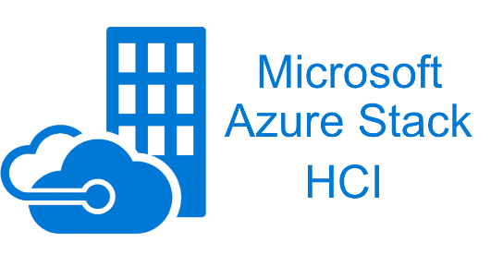

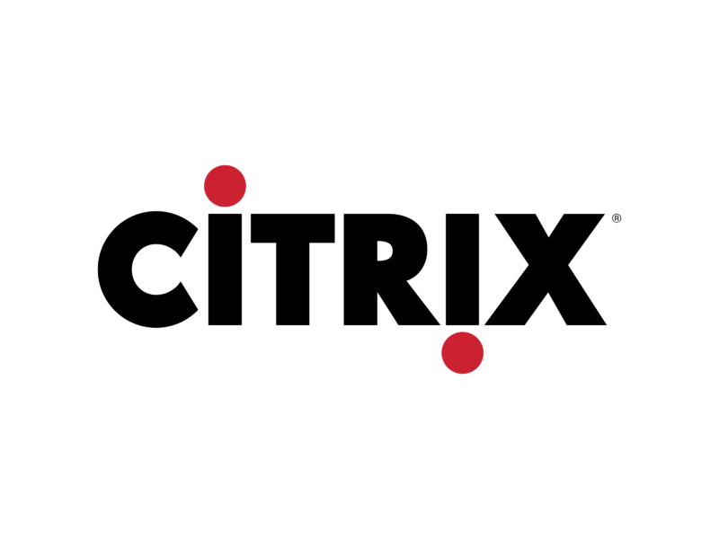

Document Research Project

Research Project

**Installation Manual** – Vandale Ward, De Herdt Mathias & Demuynck Simon

**Table of contents**

1 General information 2

1.1 Introduction 2

1.2 Objective of this document 2

1.3 Target audience 2

1.4 Research question 2

1.5 Chosen platforms 2

2 Proxmox 3

3 Azure Stack HCI 4

3.1 What is Azure Stack HCI 4

3.1.1 Pricing 4

3.2 Building the environment 4

3.2.1 Requirements 4

3.2.2 How can you download the ISO? 4

3.2.3 Creating the Virtual Machines 4

3.2.4 Create the domain 6

3.2.5 Windows Admin Center 13

3.2.6 In the Azure Portal 23

3.2.7 Cloud Witness 24

3.2.8 Define storage in Windows Admin Center 28

3.2.9 Enable logs and monitoring 29

3.3 The code behind everything 34

3.3.1 C#: AzureStackHCI.XML 34

3.3.2 C#: AzureStackHCI.XML.CS 35

3.3.3 XML: config.xml 38

3.3.4 Powershell: check-PathXML 38

3.3.5 Powershell: check-BootDevicePath 38

3.3.6 Powershell: check-BootDeviceExtention 39

3.3.7 Powershell: read-DataFromXML 39

3.3.8 Powershell: create-VirtualMachine 41

3.3.9 Powershell: migrate-VirtualMachineToCluster 42

3.3.10 Powershell: main-Script 43

3.3.11 Powershell exit codes 43

3.4 Migrate VM 43

3.4.1 Step 1: Select a VM 43

3.4.2 Step 2: Convert vmdk to vhd 45

3.4.3 Step 3: Start the migration GUI 46

3.4.4 Step 4: Start the powershell script on the azure node 49

3.4.5 Step 5: Windows Admin Center 50

4 Citrix 51

# General information

## Introduction

This document has been prepared by Vandale Ward, De Herdt Mathias and Demuynck Simon, third year students at Howest in the field of MCT – IoT Infrastructure Engineer.

In our second semester we have a module called research project in which we have chosen a research question in our field of education. During this module, which lasts three weeks, we will fully research, elaborate and document our research question.

For our research question we have chosen for: “What alternatives exist to VMware vSphere for server virtualization in an enterprise environment and how can an existing VMware environment be migrated to it?” Each of us has chosen a different platform and we are going to work this out in detail. Ward chose Proxmox, Mathias chose Azure Stack HCI and Simon chose Citrix.

What do we want to achieve with this research question? We are looking what platforms are there as alternative for vSphere and on the other hand how do we migrate to them. This is what we are trying to answare with our research question.

## Objective of this document

This document describes in detail how we build our environment, how everything works and a technical explanation for how we migrate to our platform of our choosing.

## Target audience

System administrators that are looking for different platforms for there enviroment and how they can migrate to it from a technical point of view.

## Research question

What alternatives exist to VMware vSphere for server virtualization in an enterprise environment and how can an existing VMware environment be migrated to it?

## Chosen platforms

* Proxmox
* Azure Stack HCI
* Citrix

# Proxmox

# Azure Stack HCI

## What is Azure Stack HCI

“Azure Stack HCI is a new hyperconverged infrastructure (HCI) operating system delivered as an Azure service.” – [Azure](https://azure.microsoft.com/en-us/products/azure-stack/hci/#overview)

It can make use of Azure services like:

* Cloud backup
* Site recovery
* Cloud based (security) monitoring

### Pricing

The first 2 months are free but after that you pay 9 dollars each month for every core in your cluster. So when you have a cluster with 16 cores you pay 16x9 dollar per month.

Azure Stack HCI does checks on how many physical cores you have and sends that information to Azure for billing.

You can also make use of Azure services, this will be linked to your Azure Subscription account.

Windows Admin Center is a free software that you use with Azure Stack HCI.

You also get the latest updates and features without paying extra.

## Building the environment

### Requirements

For this demonstration I’m building the cluster with the bear minimum. This will also be not as optimale because we are virtualising inside virtualisation, keep this in mind.

Before we can start we need a few things.

* 2 Windows servers 2022
  + 1 for the domain controller (DC)
  + 1 for running admin center, this can’t be a domain controller because this is not supported.
* 2 Azure Stack HCI machines (nodes)

### How can you download the ISO?

This can be downloaded from [azure.microsoft.com](https://azure.microsoft.com/en-us/products/azure-stack/hci/hci-download/?WT.mc_id=modinfra-11860-thmaure), after registration you get an email with the download link for the ISO, keep in mind this is a free trail version for only 60 days.

### Creating the Virtual Machines

The Azure Stack HCI machines should ideally be on dedicated hardware, it is not at all recommended to use VMs. When using VMs you will have a huge performance problem.

The minimum requirements:

* 2 nodes
* 4 SSD or 2 SSD + 4HDD per server
* No minimum processor and memory
* 1 x 10 Gbps network adapter

The maximum requirements:

* 16 nodes
* 16 000 TB storage per clusters

My virtual machines, once again this is not best practice and was used in a testing environment.

In my case I used 2 nodes with identical specs.

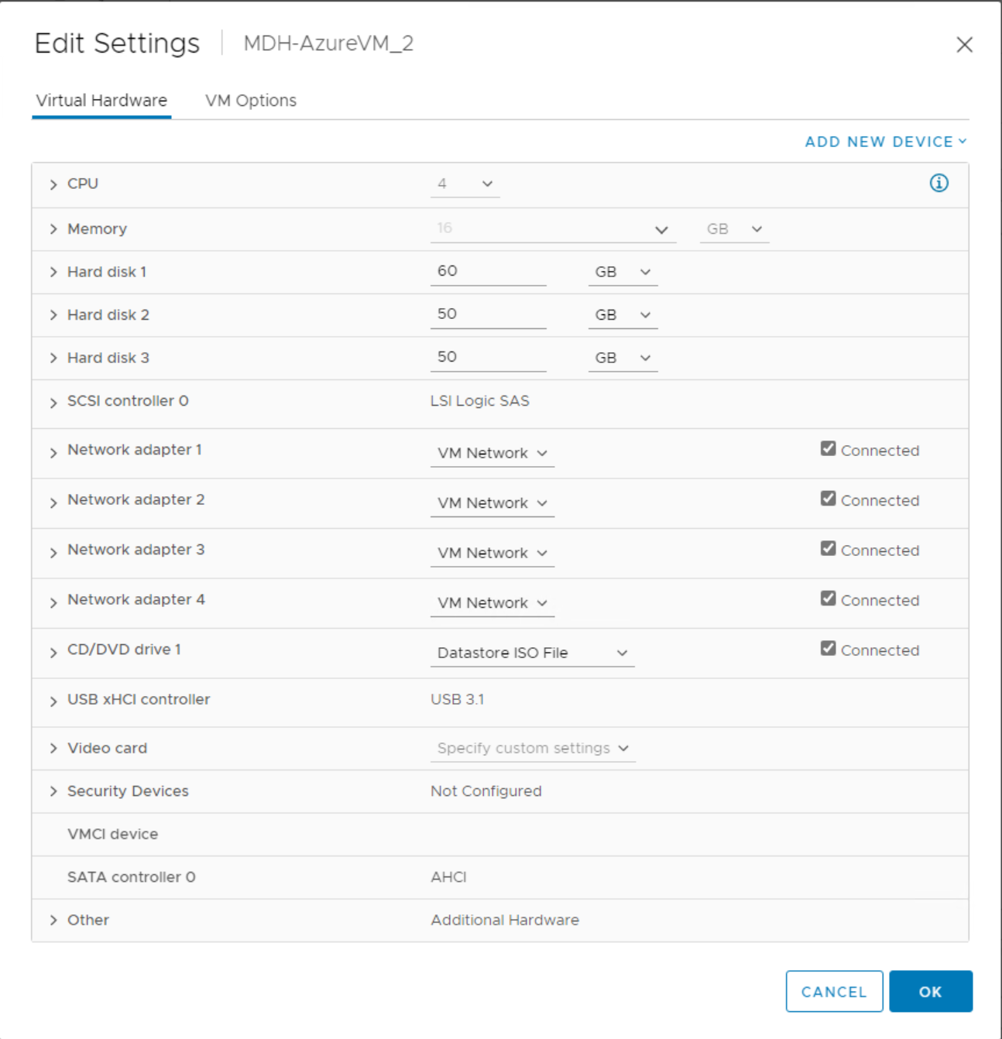

Make sure under CPU that hardware virtualization is enabled.

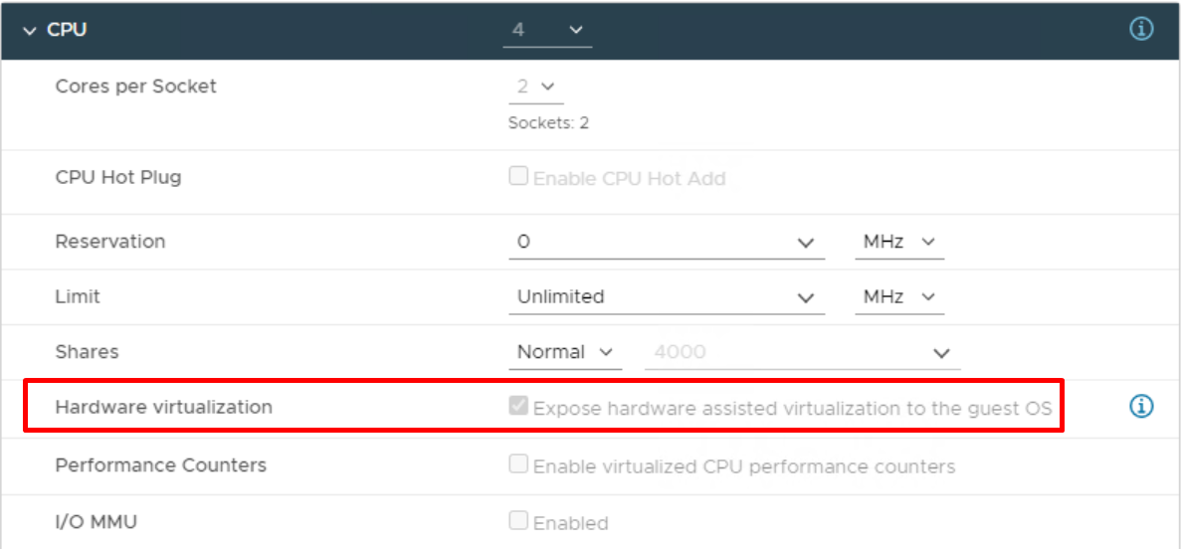

### Create the domain

On the DC in server manager we need to add some roles and features.

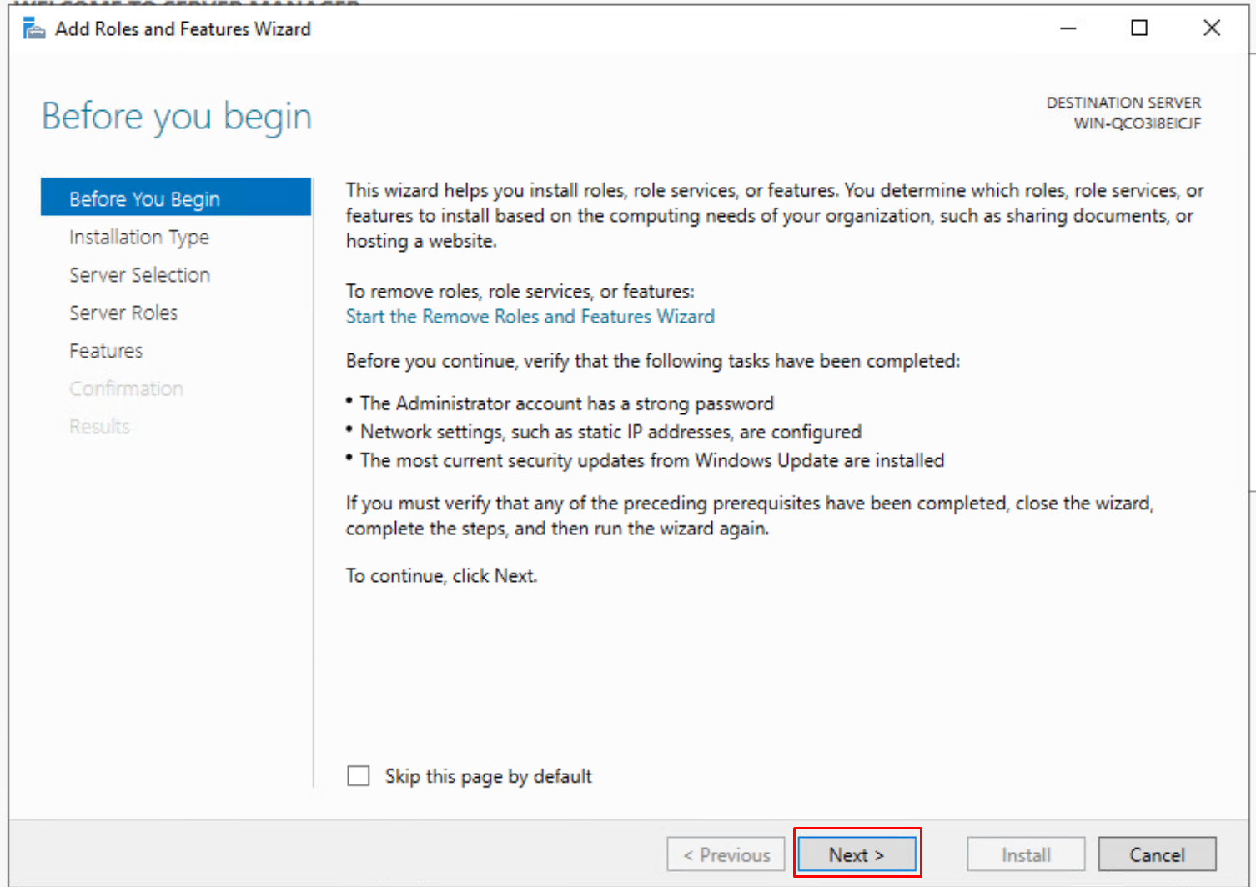

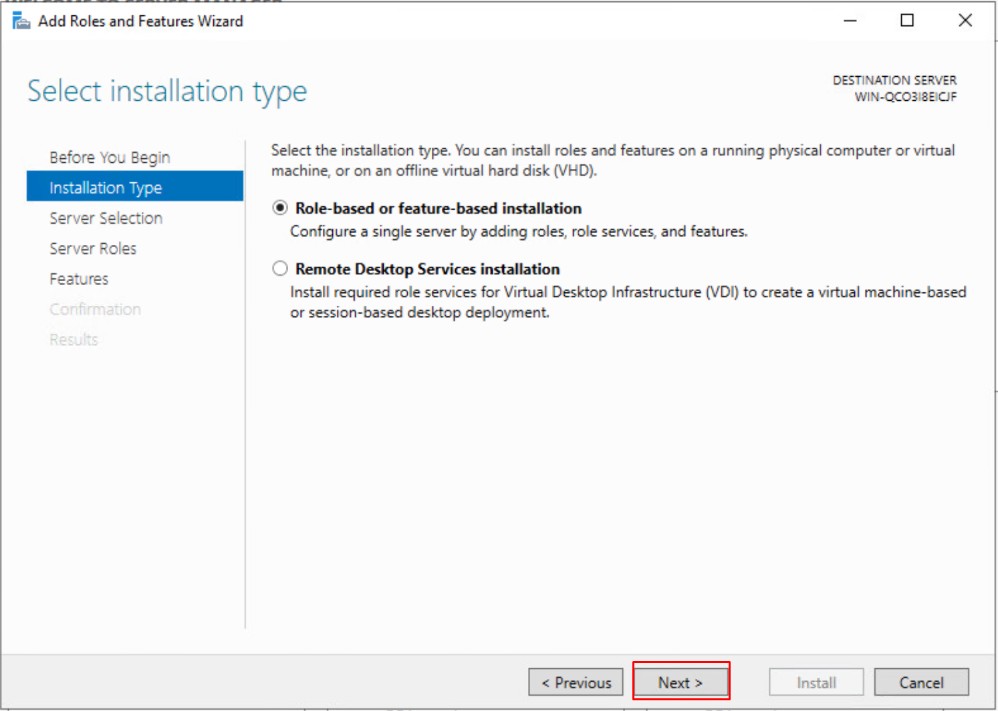

Select your server, in this case it will be the DC.

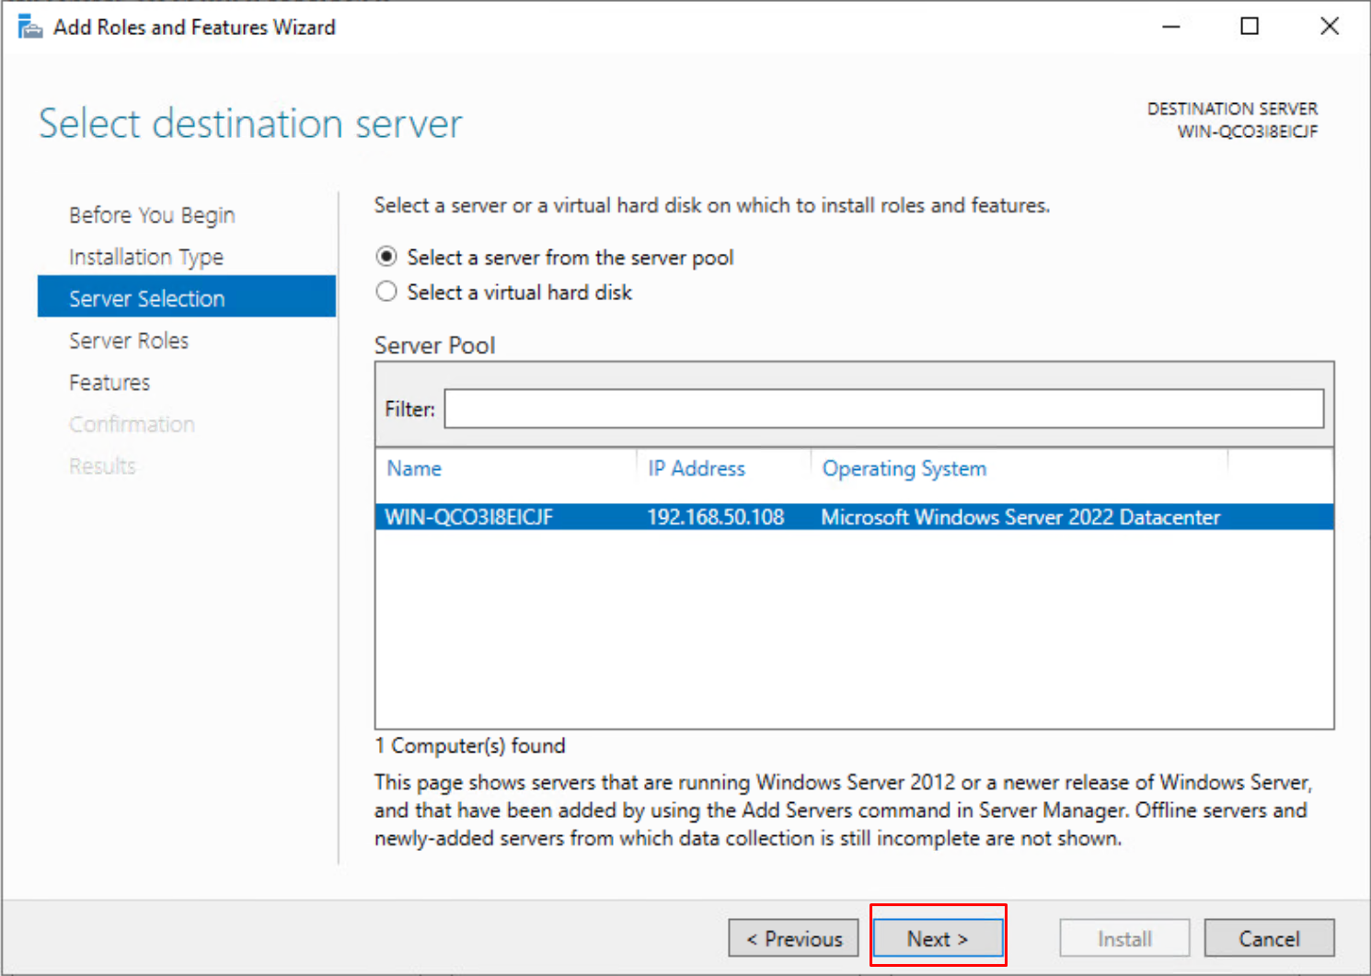

Here we must install “Active Directory Domain Services”. This is needed for creating the domain.

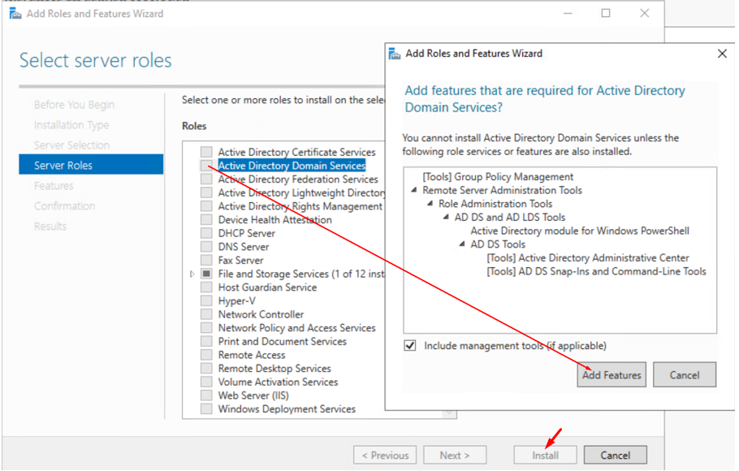

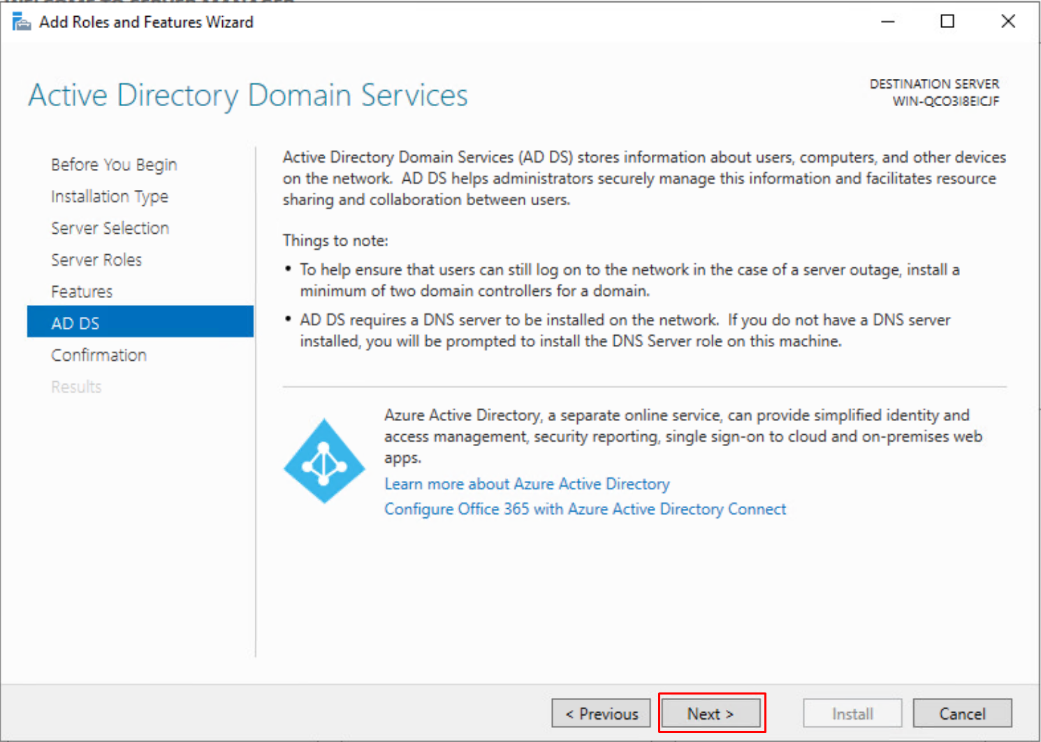

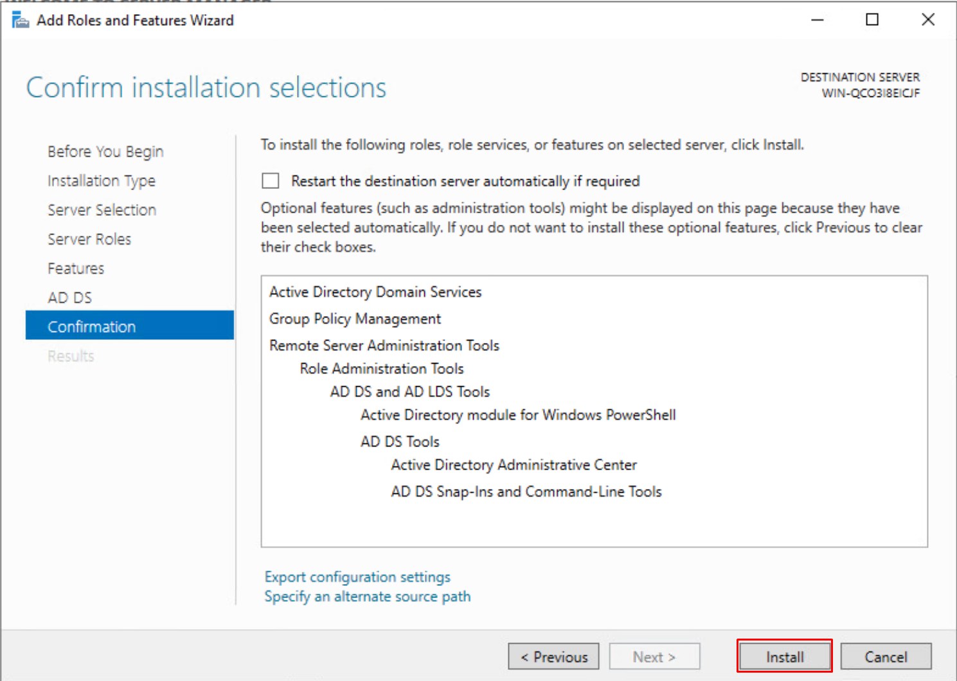

Back on the server manager in the right hand corner you should see this after the installation.

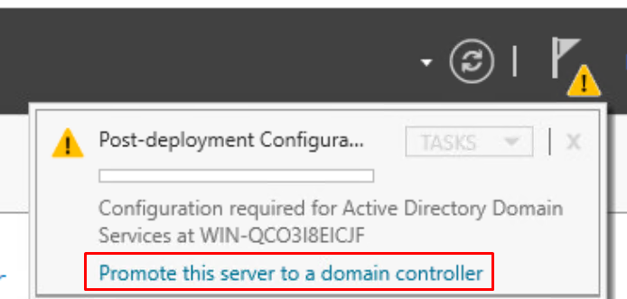

We create a new forest and enter the root domain name

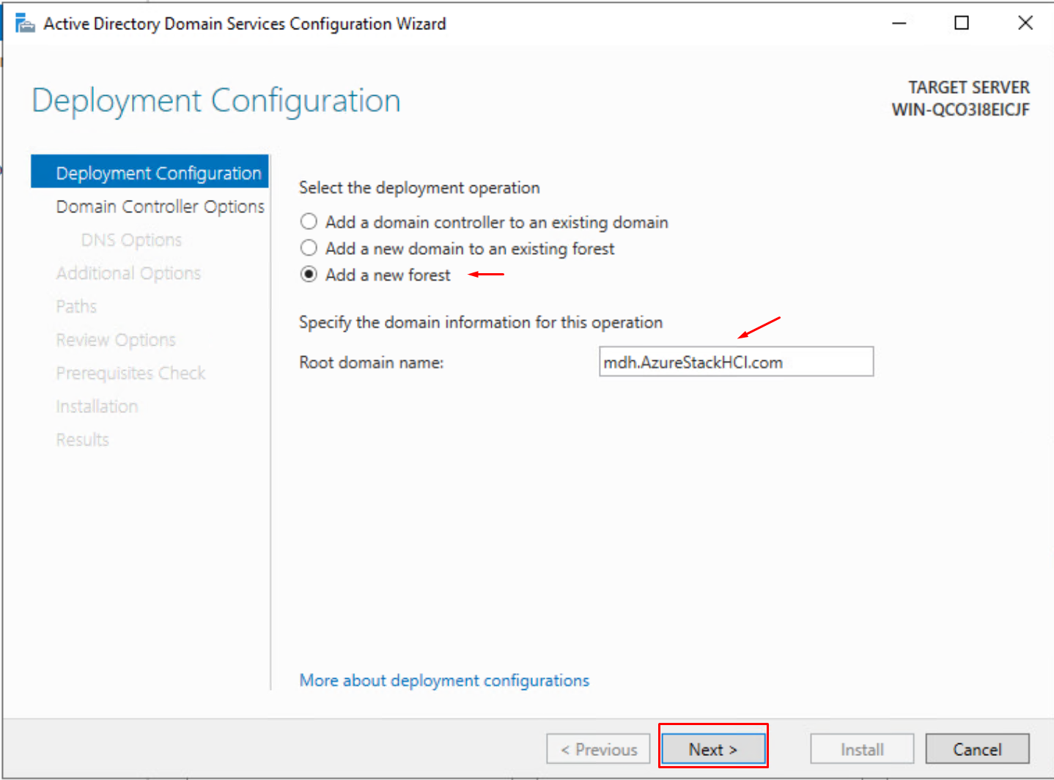

Give your deomain a strong password, in my test environment I used a weak password that never should be used in a production environment!

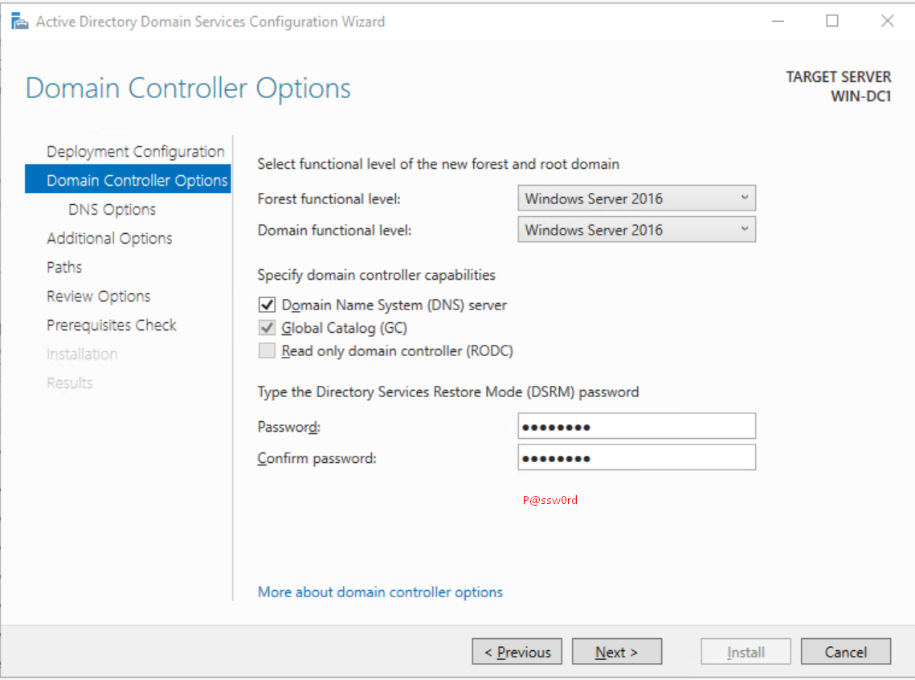

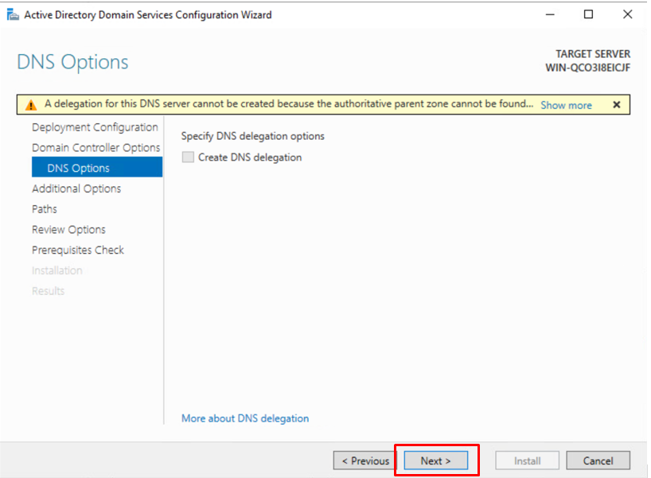

This is automatically generated, wait a few seconds for it to load.

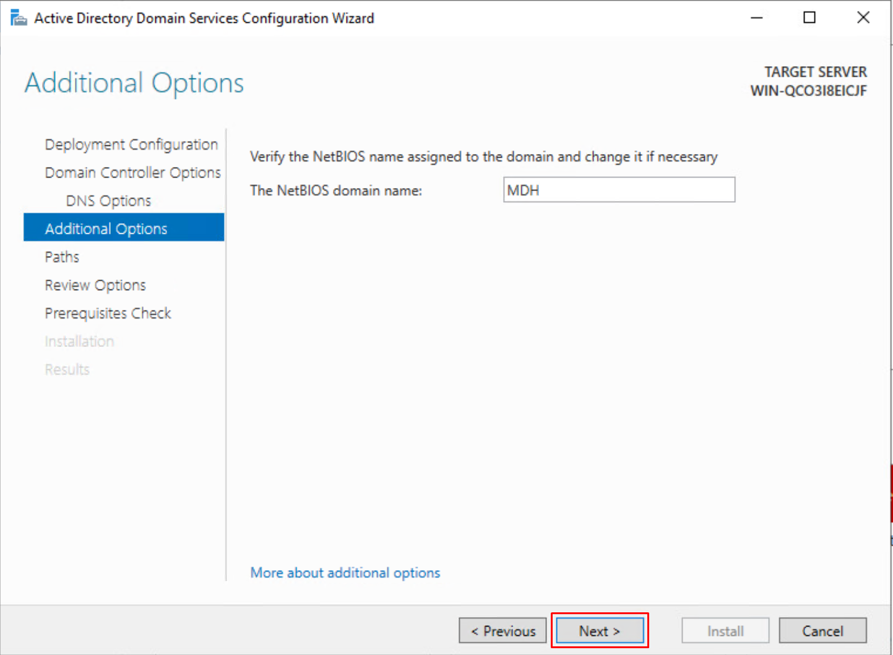

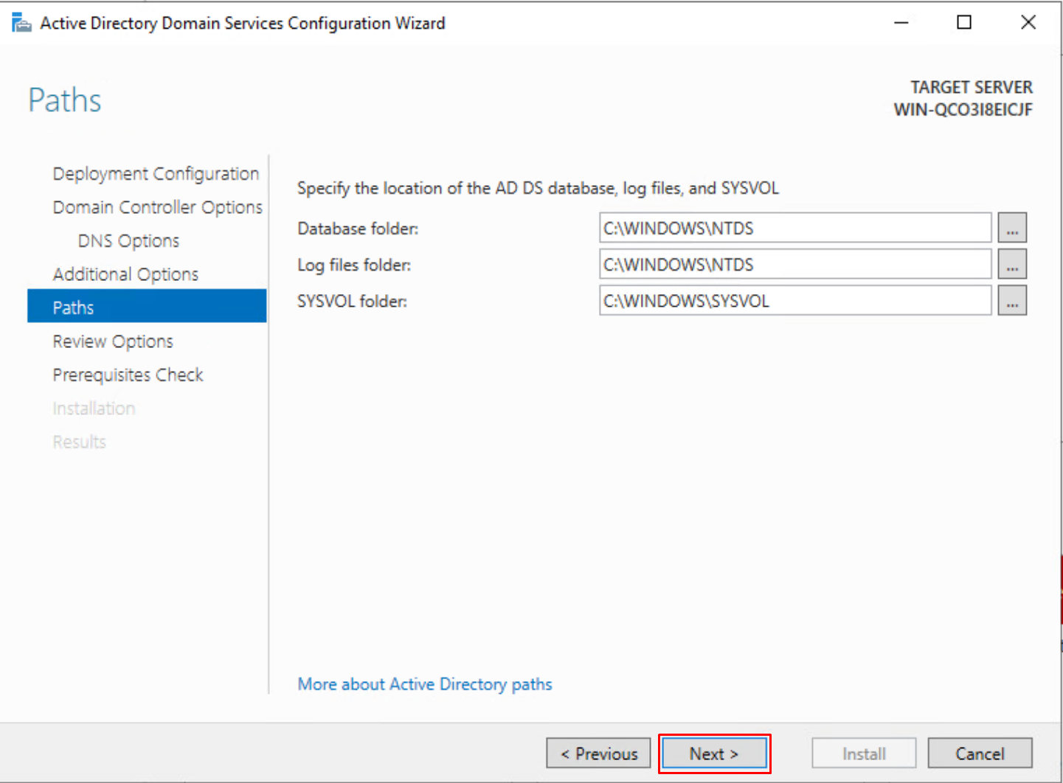

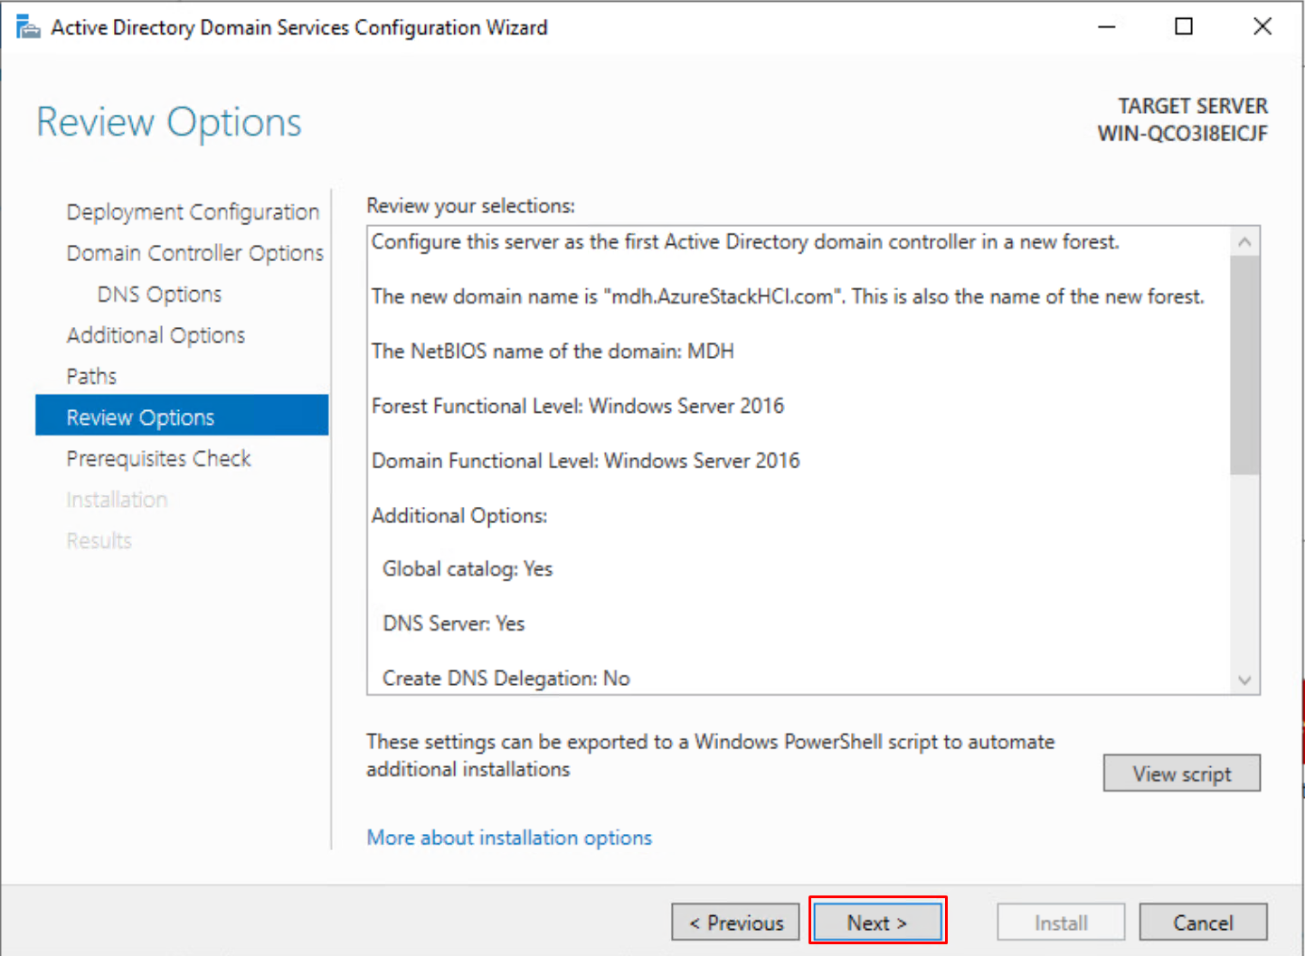

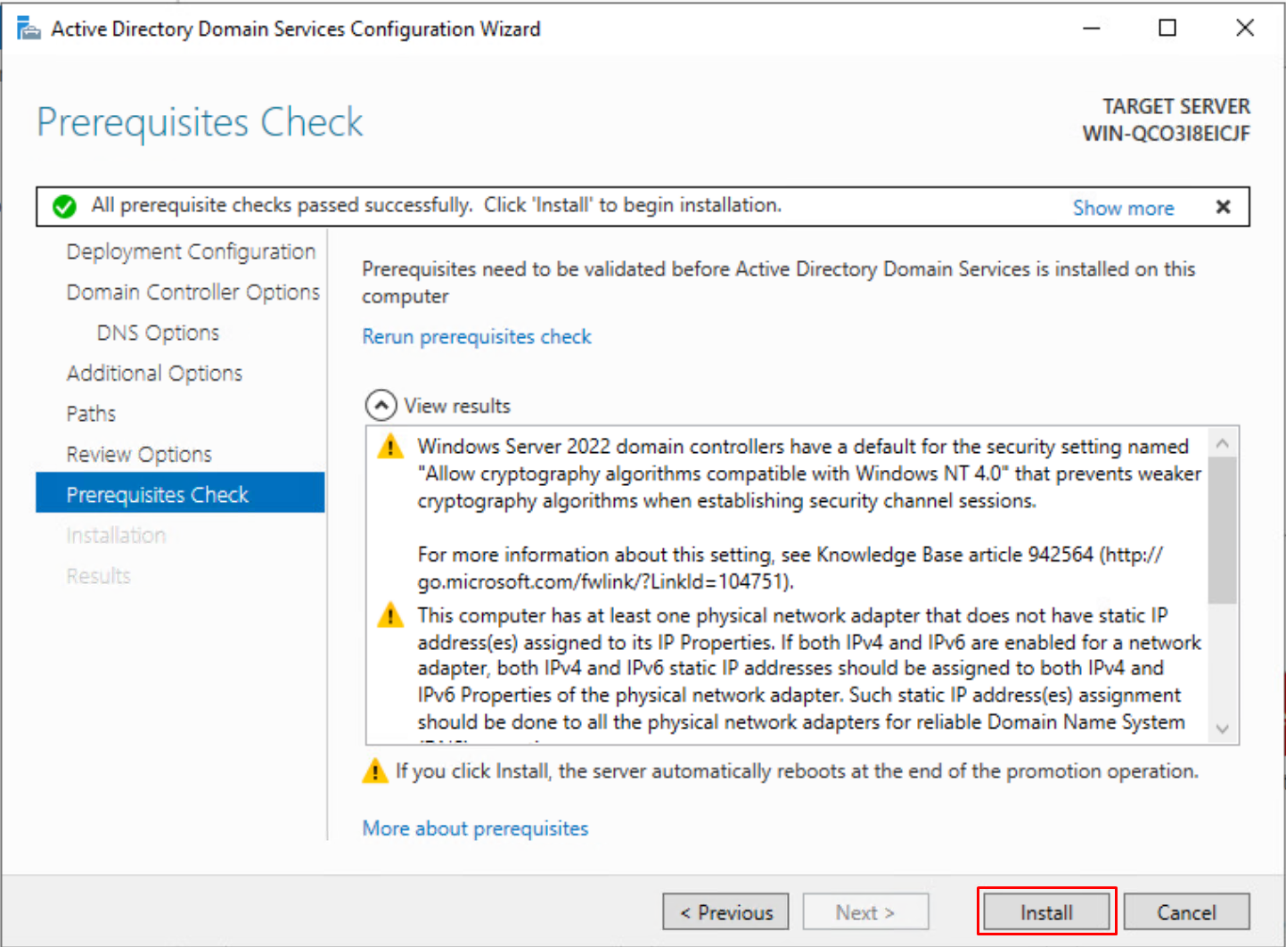

After the domain is created, all the other VM’s must join the domain. You can do this manually now or later in Windows Admin Center. I choose to do it now. Keep in mind Windows Admin Center only adds our Azure Stack HCI VM’s to our domain. From now on the Azure Stack HCI VM’s will be called nodes, because they are nodes from the cluster that we are building. The other windows server (that will be running Windows Admin Center) we must join it ourselves to the domain.

### Windows Admin Center

#### What is Windows Admin Center?

A tool for remote server management.

* You can manage servers
* Create clusters
* Create virtual machines
* Create servers

#### Install Windows Admin Center

Is a free to download software at this link.

<https://www.microsoft.com/en-us/evalcenter/evaluate-windows-admin-center>

#### Configure Windows Admin Center

[https://win-admincenter.mdh.azurestackhci.be](https://win-admincenter.mdh.azurestackhci.be/)

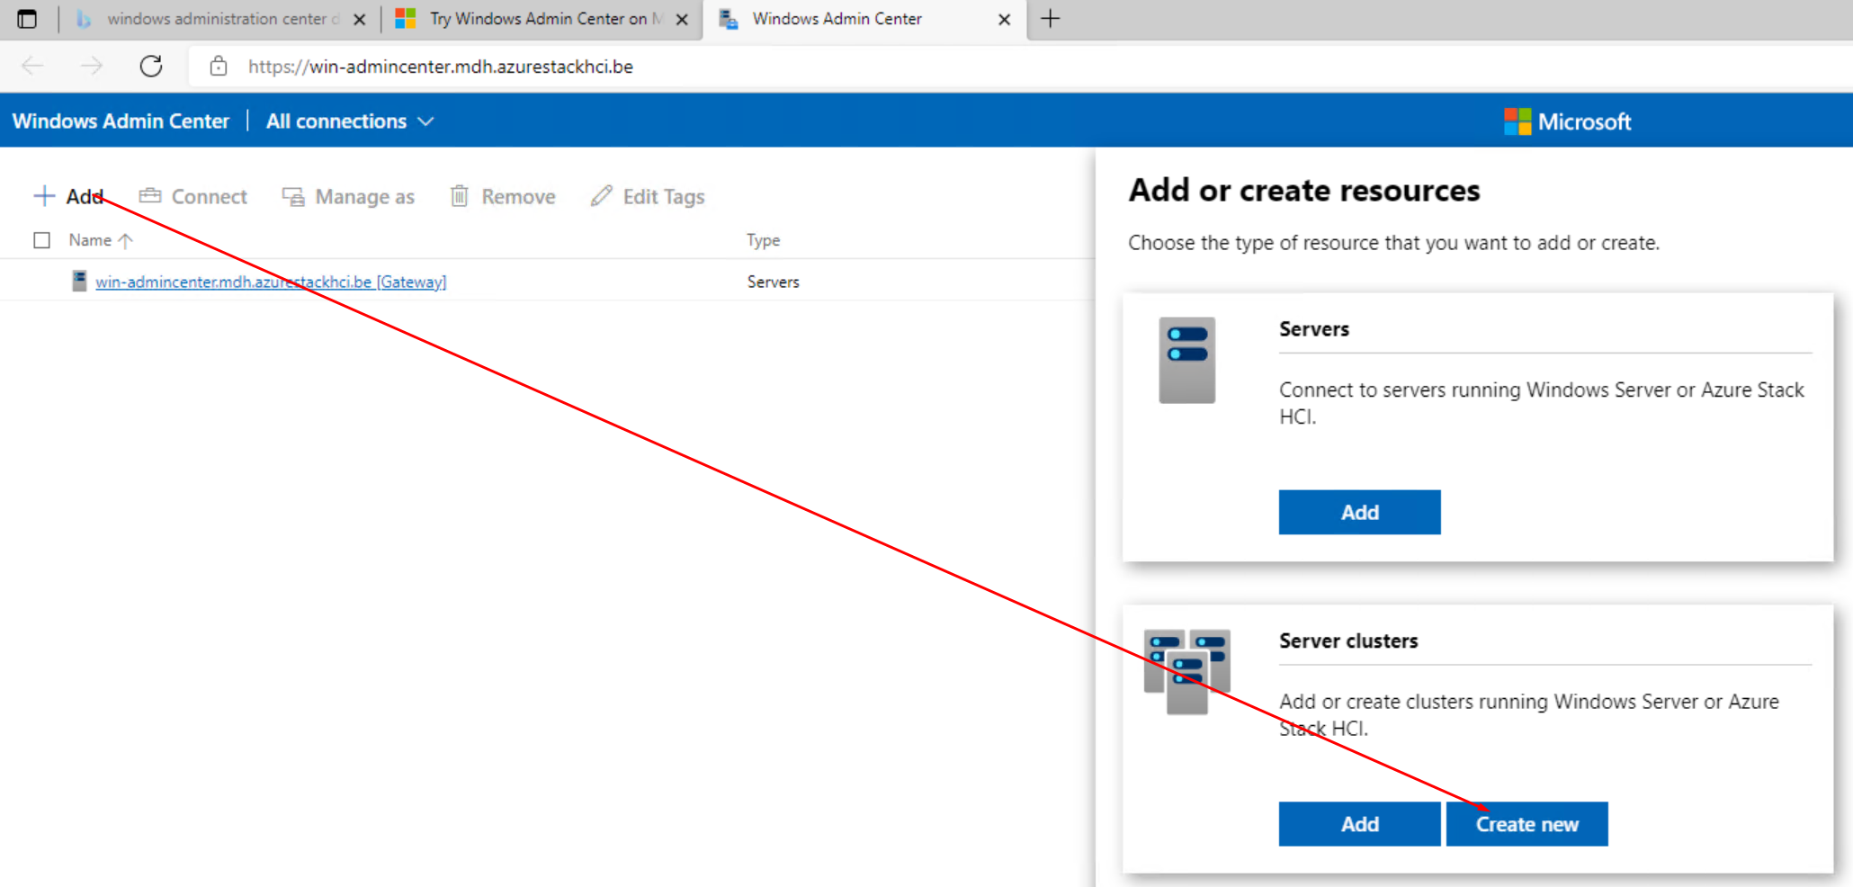

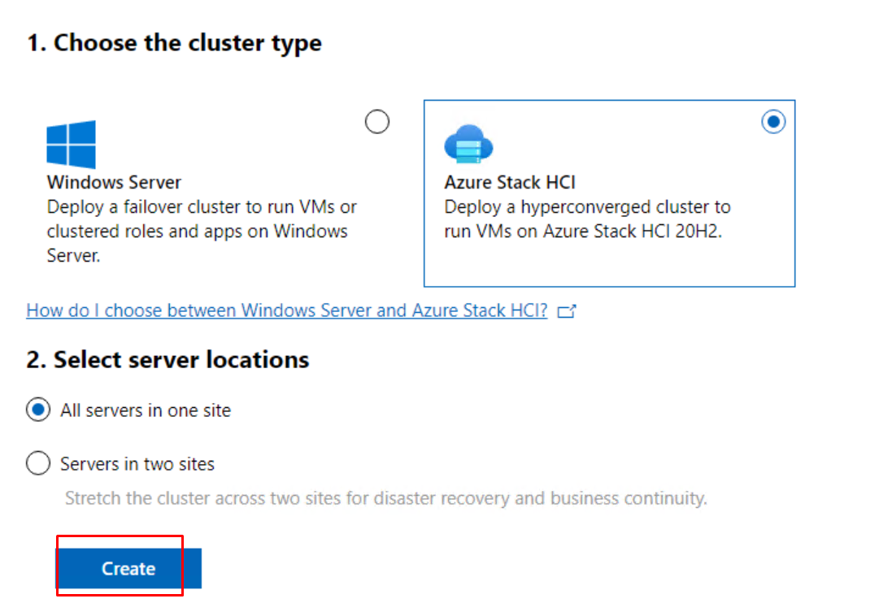

Here we must add our 2 nodes. You can do this by IP address or hostname. Make sure that the username and password match those of the nodes.

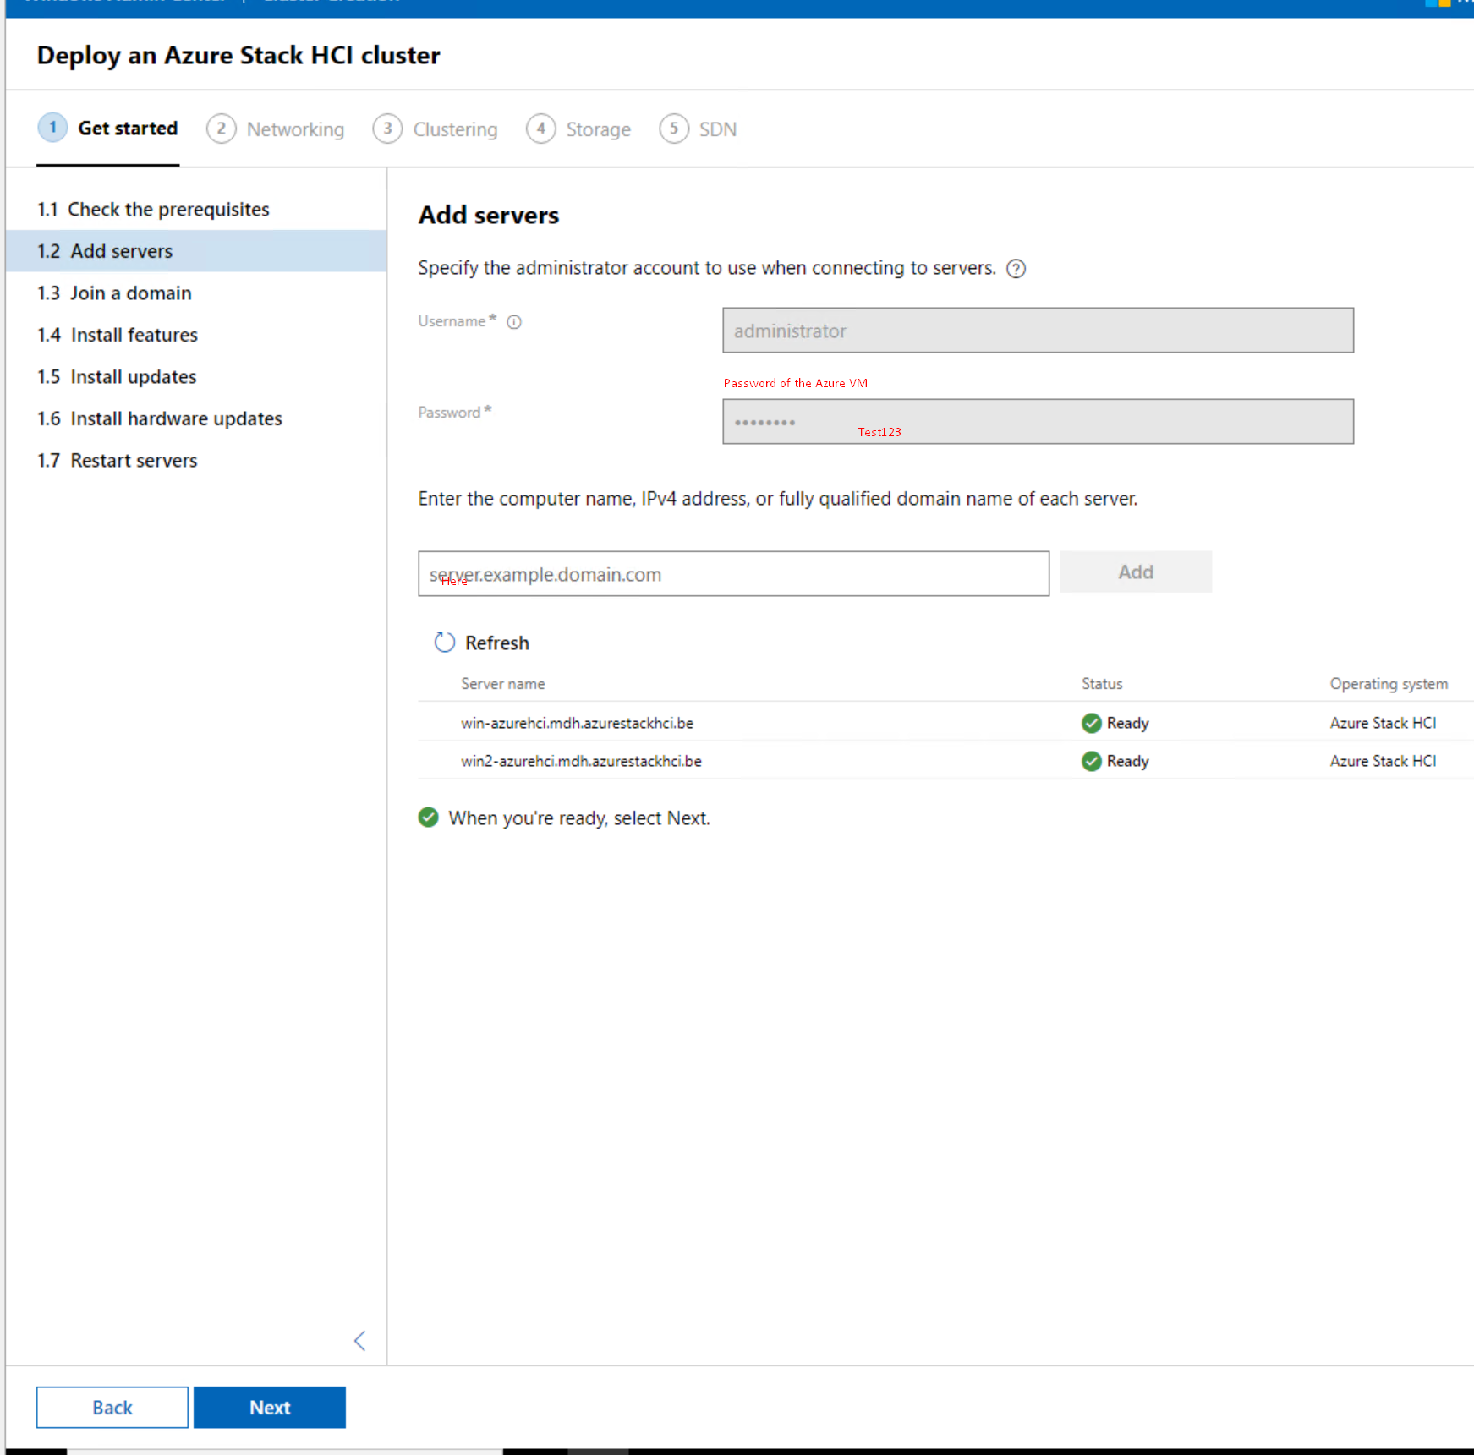

Here we can join our 2 nodes to the domain if needed.

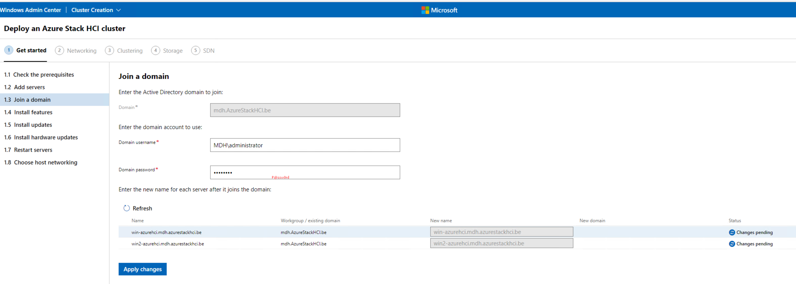

Install required features to the nodes, here I encounterd a problem with on of the features. Hyper-V has trouble installing, I found a solution to this problem. Best to manually install the feature on the nodes with the following powershell command:

Enable-WindowsOptionalFeature -Online -FeatureName Microsoft-Hyper-V -All

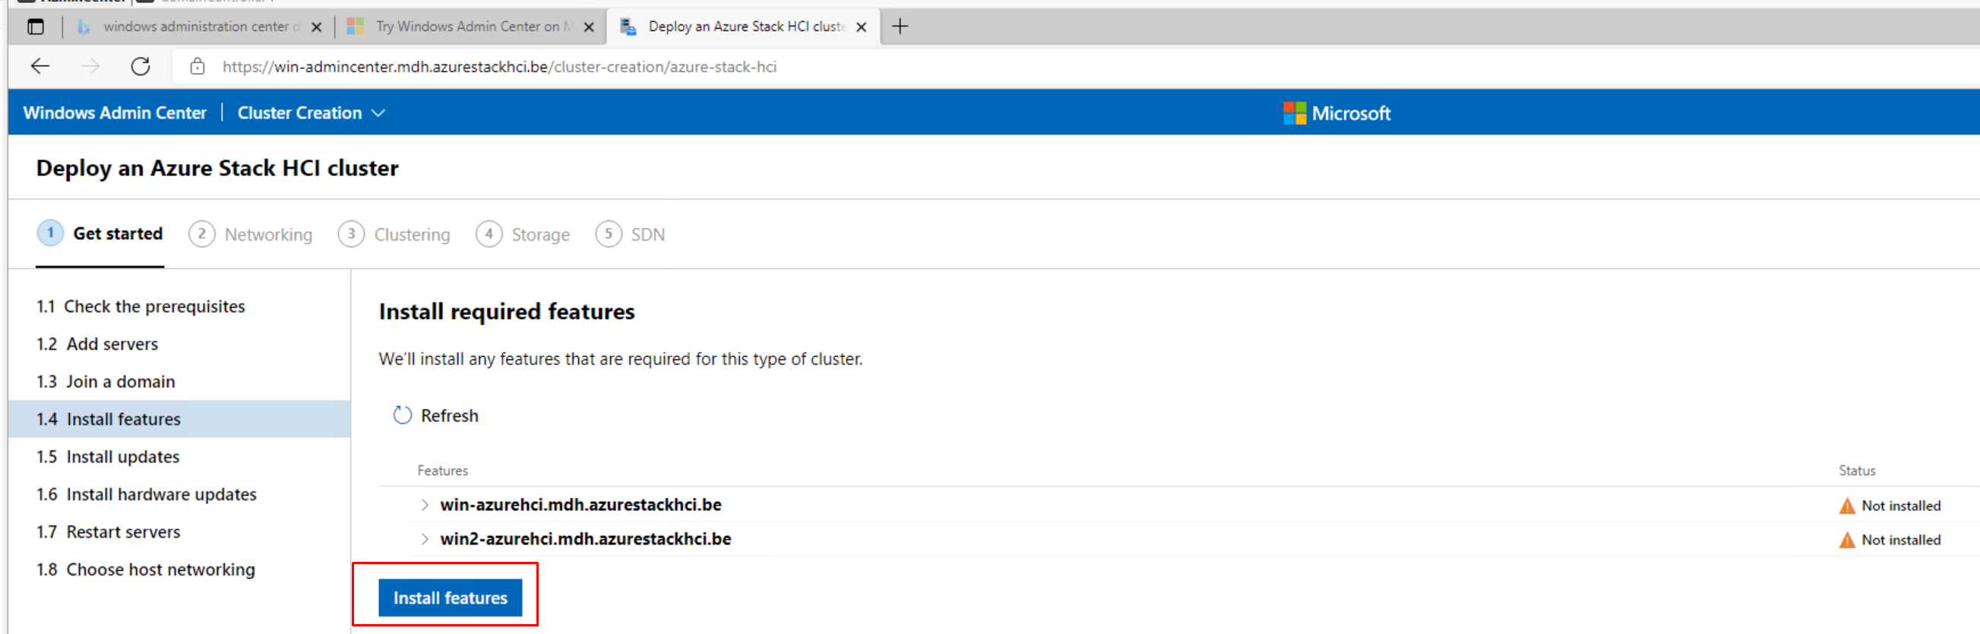

After all the required features are installed we can go to the next step.

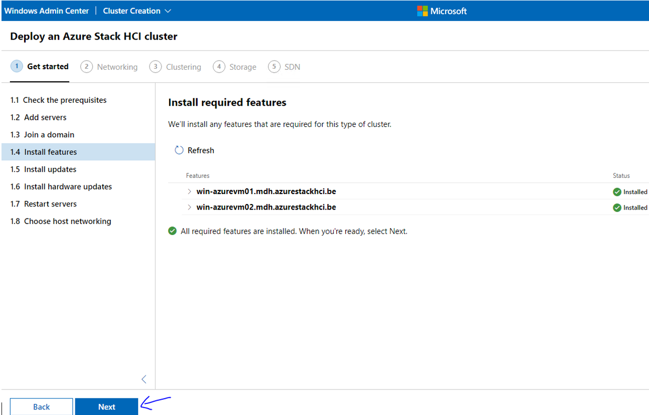

Install the latest Windows updates

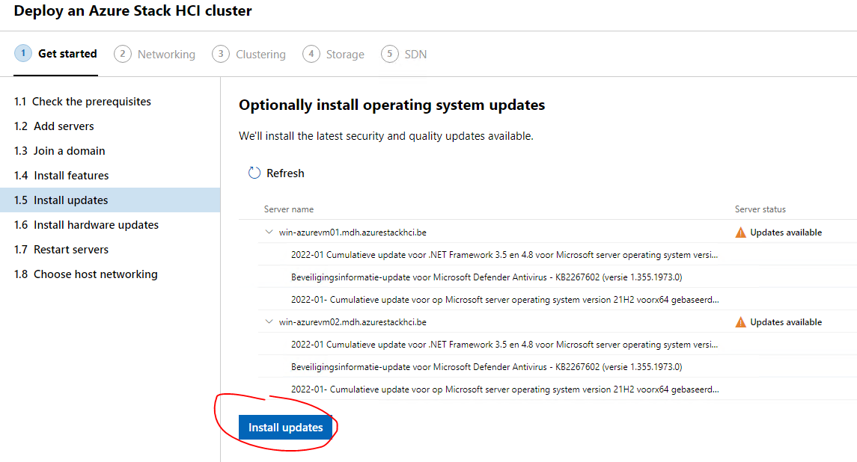

After the installation we can go the the next step “Install hardware updates”, we can just press next here. Now at the next step we must reboot our nodes. After the nodes are back online go to the next step “Choose host networking”. Here we choose to manually configure the host networking.

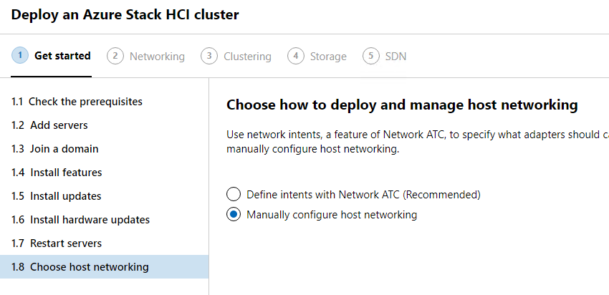

In the first step of the Networking tab, Windows Admin Center checks our network adapters and sees how many we have. After this step is completed we can go to the next one.

Here I made a mistake, I chose for the second node the wrong adapter first, that’s why I’m not selecting “Management” here. For both VM’s I want to select Ethernet0 but after you select an adapter and press next it automatically changes the name to “Management” hence why I’m selecting Ethernet0 on the second VM and not the adapter with the name “Management”.

Is this crucial that both of them are Ethernet 0? Well not really but for consistency and Clarity it is important.

After selecting the right adapters we can go to the next step.

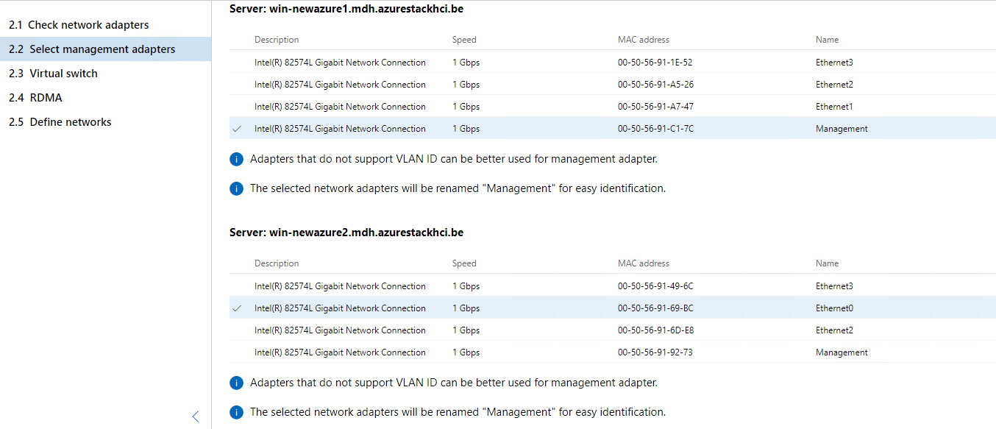

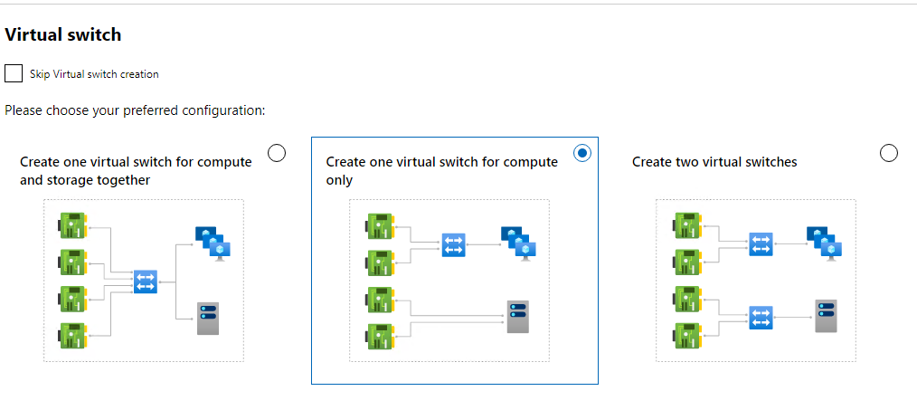

Here we both select Ethernet1, keep in mind that the name on the second node is not Ethernet1 because that was the old management adapter that I by accident chose in the previouse step.

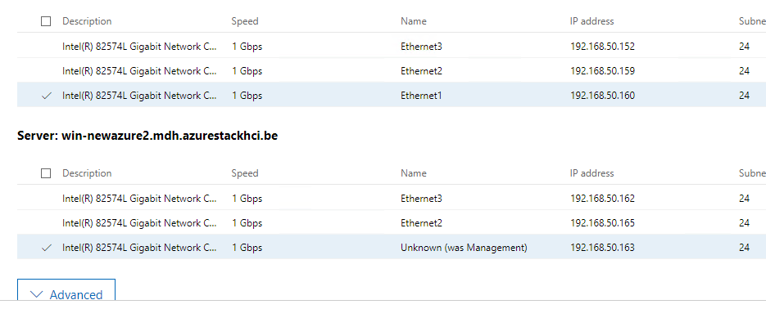

Here in the final step of Networking we can change the network configuration of the adapters if needed.

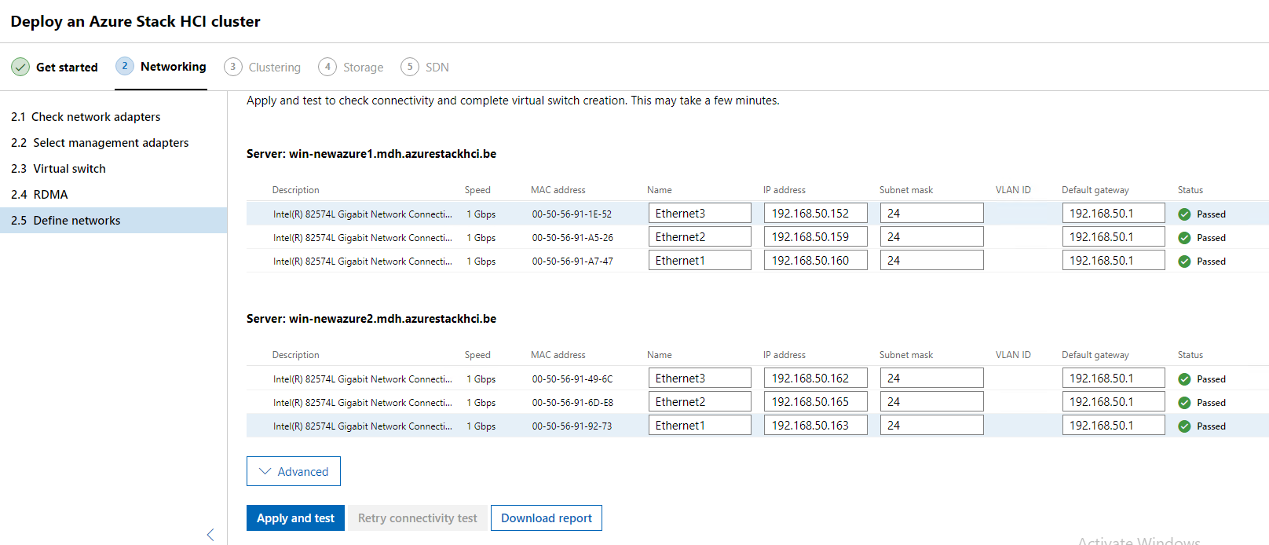

Here we are creating the cluster, but first we must validate it. After the validation we can give the cluster a name and an IP address.

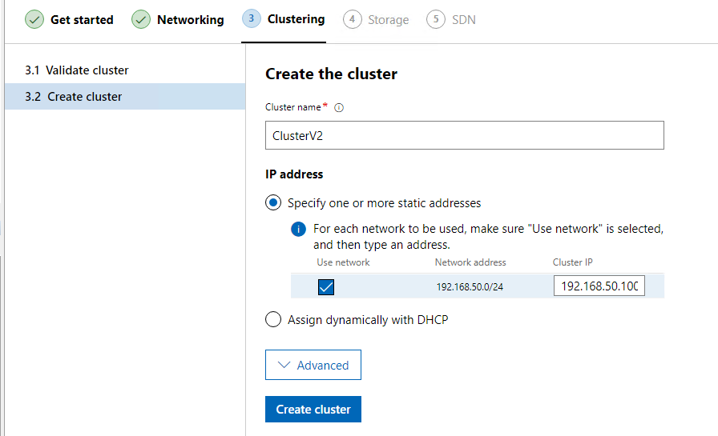

On the final tab “Storage” we are going to check and validate our storage on the nodes.

Here we can erase the drives, keep in mind that it removes everything on the disks except the OS.

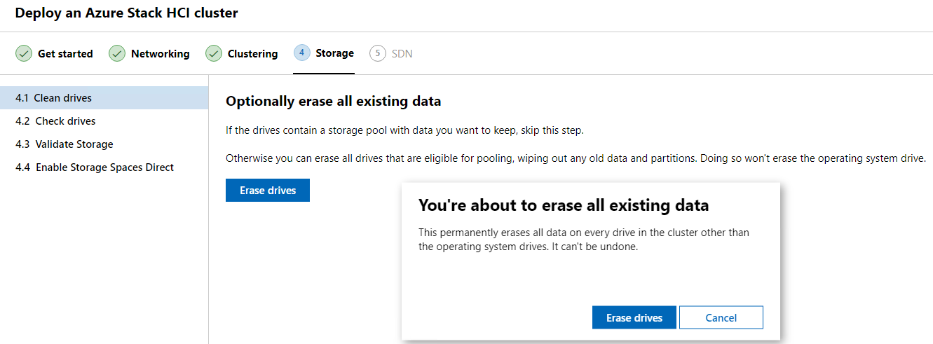

Here we can see our storage that is attached to our nodes.

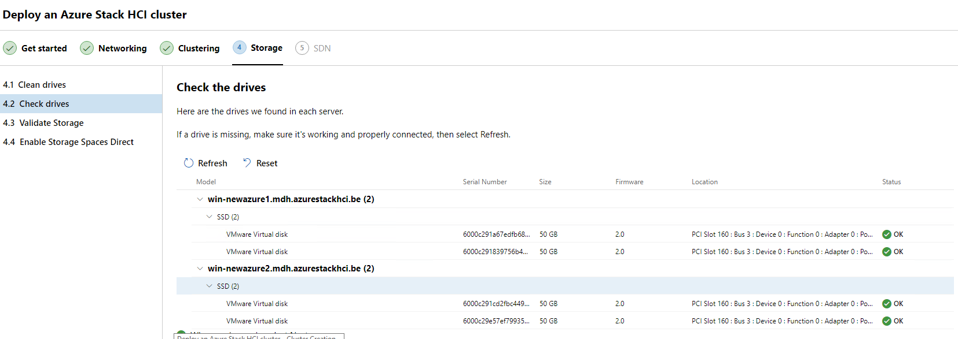

Next Windows admin Center is going to validate the storage, after the validation we can go to the last step “Enable Storage Space Direct”.

Select enable.

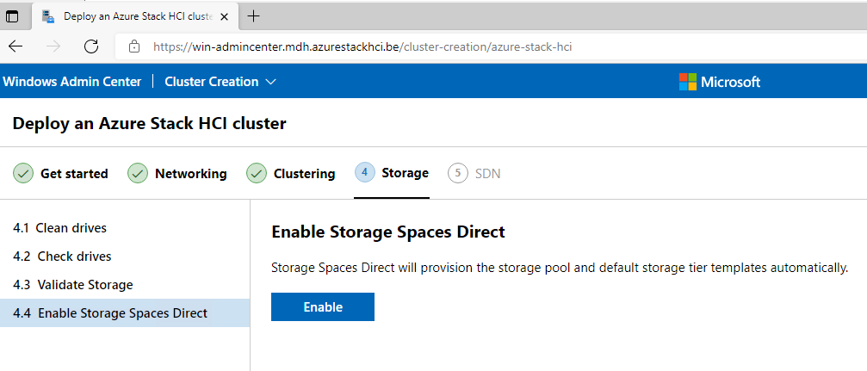

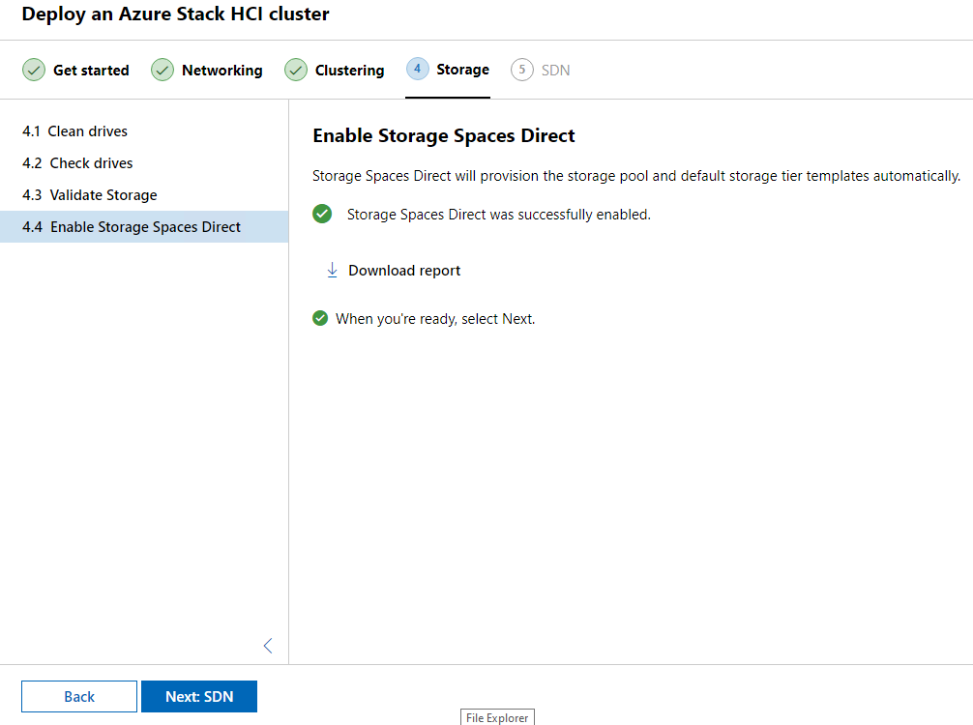

Now go to SDN but here you can skip this part, this is not needed in my case.

#### Powershell

On our Windows Server that runs Windows Admin Center open powershell. This are the commando’s that are needed.

# Install the modules

# ------------------------

# install the necessary components on the azure stack HCI nodes

$nodes = "WIN-NEWAZURE1", "WIN-NEWAZURE2"

Invoke-Command -ComputerName $nodes -ScriptBlock {

install-windowsfeature RSAT-Azure-Stack-HCI

}

# install the powershell module locally

Set-ExecutionPolicy -ExecutionPolicy RemoteSigned -Force

Install-Module Az.StackHCI

# check the current registration status

Invoke-Command -ComputerName "WIN-NEWAZURE1" -ScriptBlock {

get-azurestackHCI

}

# Registration

# ------------------------

Register-AzStackHCI `

-SubscriptionId "5805601e-eb8f-40e2-b296-28b53cc51a12" `

-ResourceName "ClusterV2" `

-ResourceGroupName "WE-MDH-AzureStack" `

-EnvironmentName "AzureCloud" `

-ComputerName "WIN-NEWAZURE1" `

-Credential $azhciNodeCreds

#### Registration explained

# Registration

# ------------------------

Register-AzStackHCI `

-SubscriptionId "5805601e-eb8f-40e2-b296-28b53cc51a12" `

-ResourceName "ClusterV2" `

-ResourceGroupName "WE-MDH-AzureStack" `

-EnvironmentName "AzureCloud" `

-ComputerName "WIN-NEWAZURE1" `

-Credential $azhciNodeCreds

* SubscriptionID = the ID of your subscription

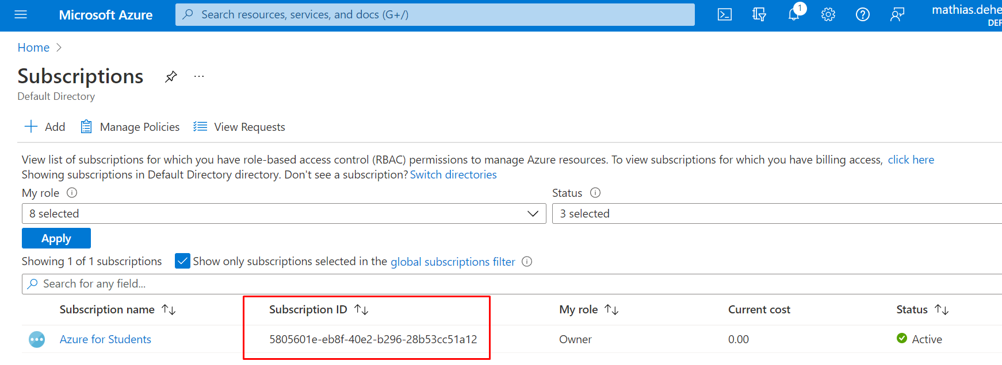

* ResourceName = the name of the cluster you created
* ResourceGroupName = the name of your resource group, keep in mind that the region North Europe is not supported for your resource group.
* EnviromentName = the name of your environment, this can be whatever you want
* ComputerName = the name of one the nodes, I choose for the first one.
* Credential = $azhciNodeCreds 🡪 this wel use the credentials of your Azure Stack HCI VM

After running the registration script block you will get a prompt to sign in, sign in with a global administrator account for Azure. This must be a global administrator account because you need certain privileges to install features.

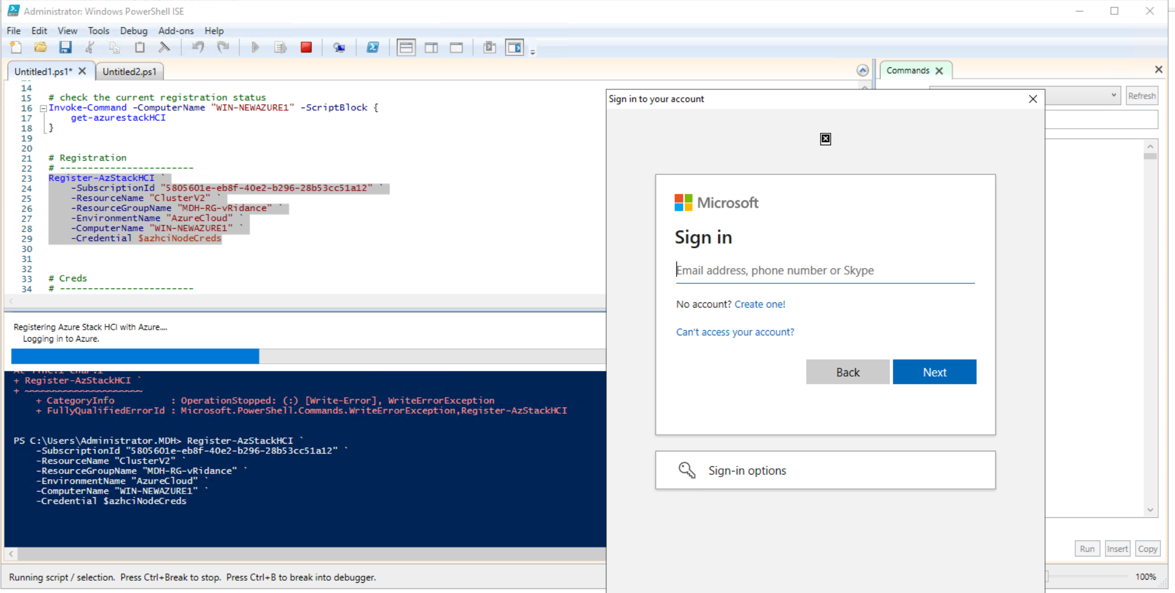

### In the Azure Portal

When we go to our resource group you can see the cluster we just created.

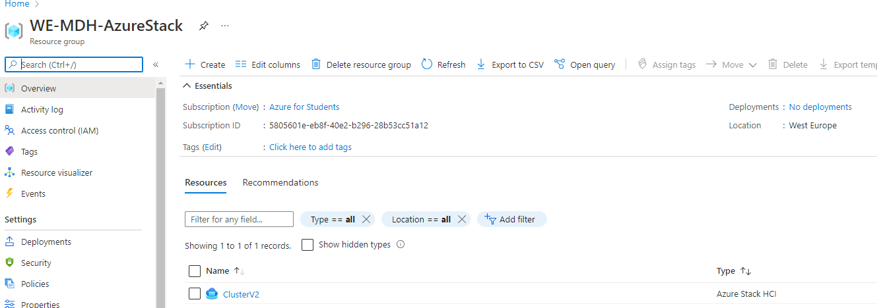

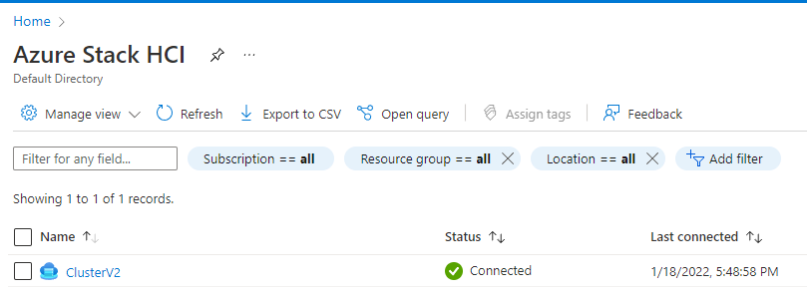

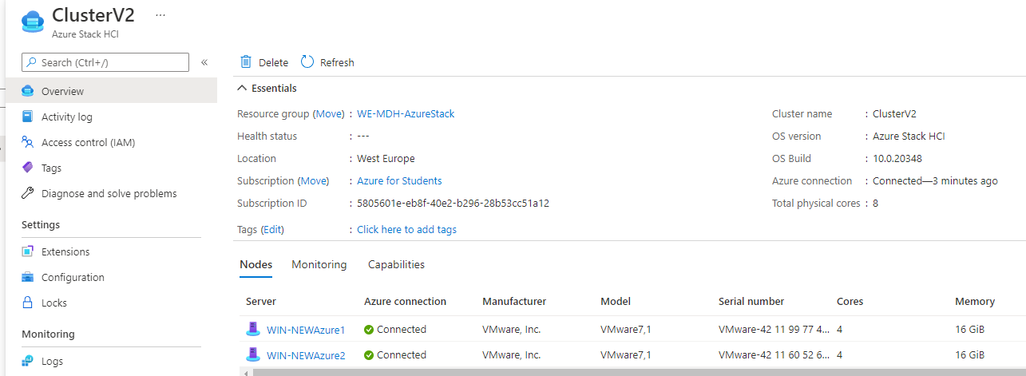

### Cloud Witness

Azure Stack HCI is the only 2 node solution with server failure protection and drive failure in a 2 node configuration. This is possible to the Cloud Witness. When one of the nodes goes offline, the Cloud Witness makes sure that the other node does not become unavailable.

3 or 4 node clusters can also make use of Cloud Witness when 2 nodes become unavailable.

The quorum for a cluster is determined by the number of votes in elements that must be part of active cluster memebership for that cluster to start properly or continue running.

Each node typically has a vote, but in our case we have an even number of nodes we use this Cloud Witness to provide the third decisive vote.

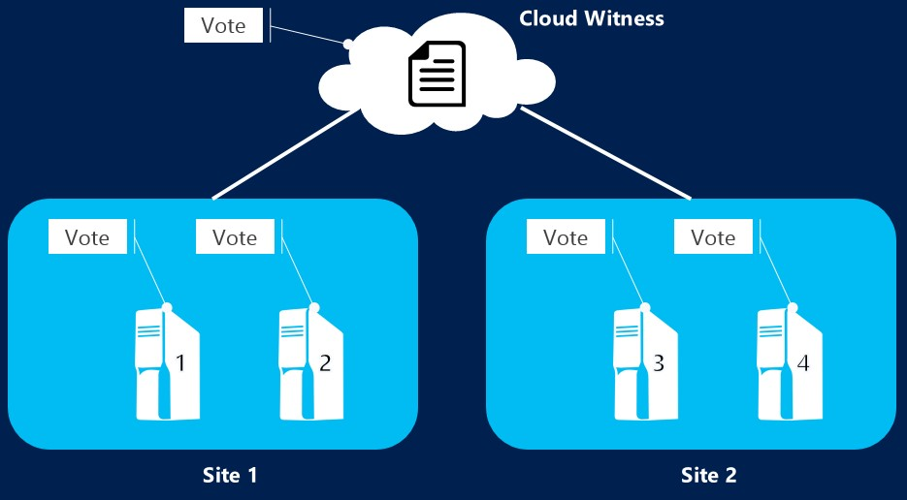

<https://docs.microsoft.com/en-us/windows-server/failover-clustering/deploy-cloud-witness>

#### Setup Cloud Witness

Go to windows Admin Center.

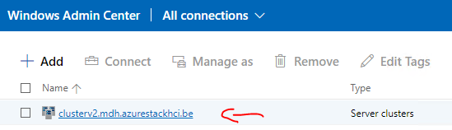

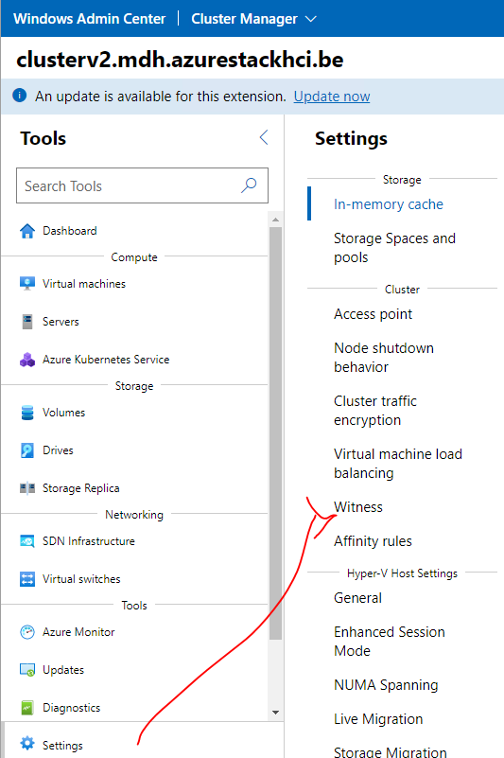

For this Witness we first have to create a storage account. After creating the storage account we will come back to this page.

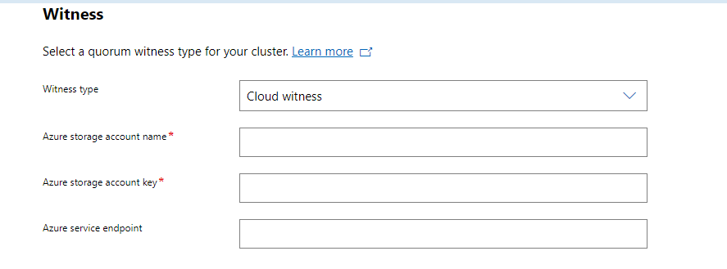

#### Storage Account

In the azure portal create a new storage account.

Make sure you put it in the resrouce group where our cluster is in and that the regions are consistend.

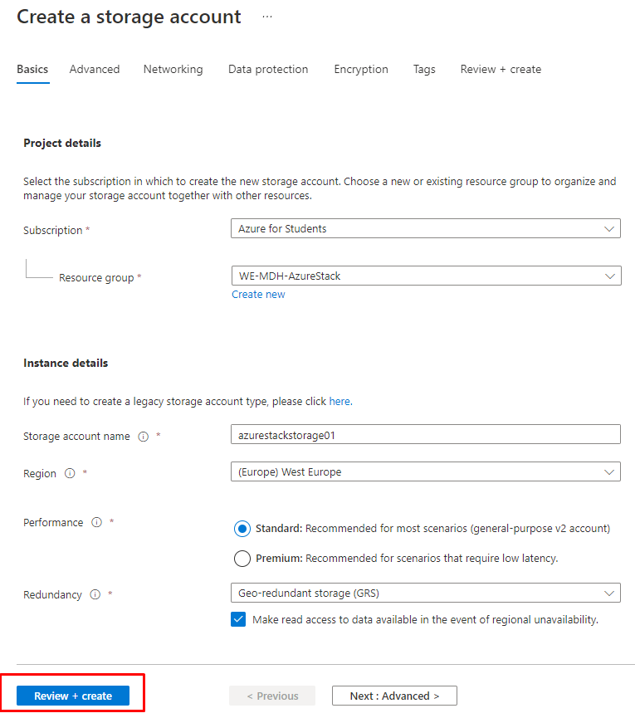

After we created the storage account go to Access keys.

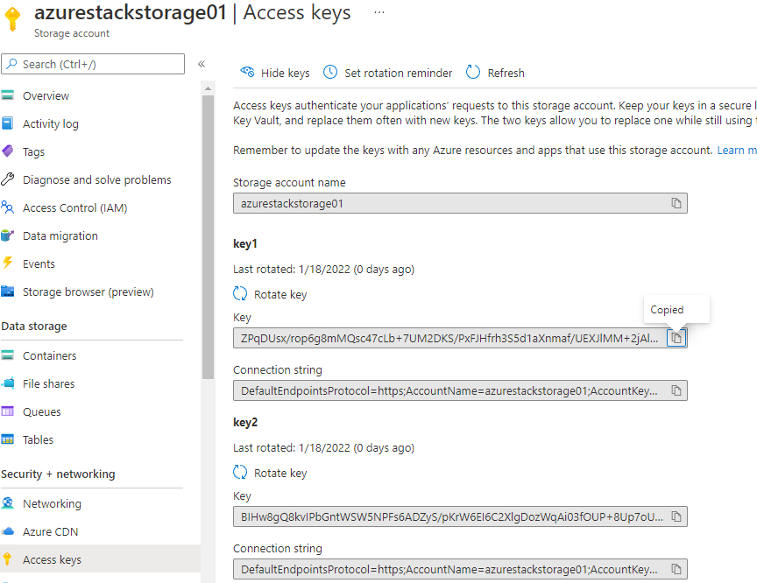

We need these credentials for our Cloud Witness.

#### Back to Windows Admin Center – Cloud Witness

* Account name = the name of the storage account we just created
* Account key = the access key we copied
* Azure service endpoint = core.windows.net -> this is a build in endpoint that we can use

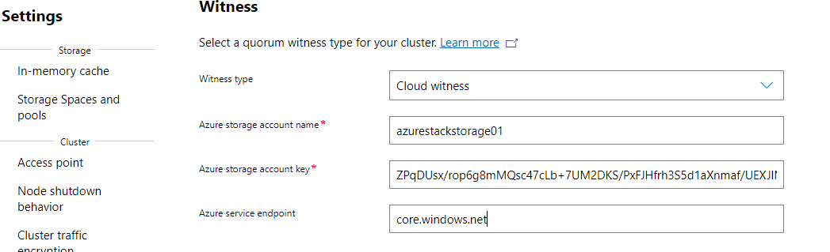

### Define storage in Windows Admin Center

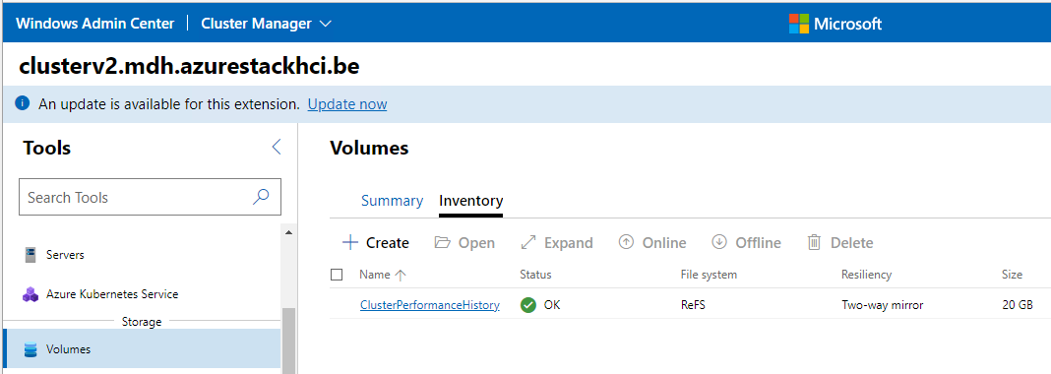

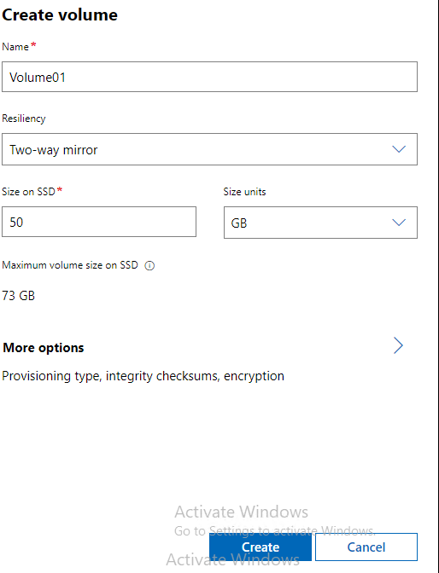

### Enable logs and monitoring

This way we can monitor our cluster in the Azure Portal. Sign in with your Azure global administrator account.

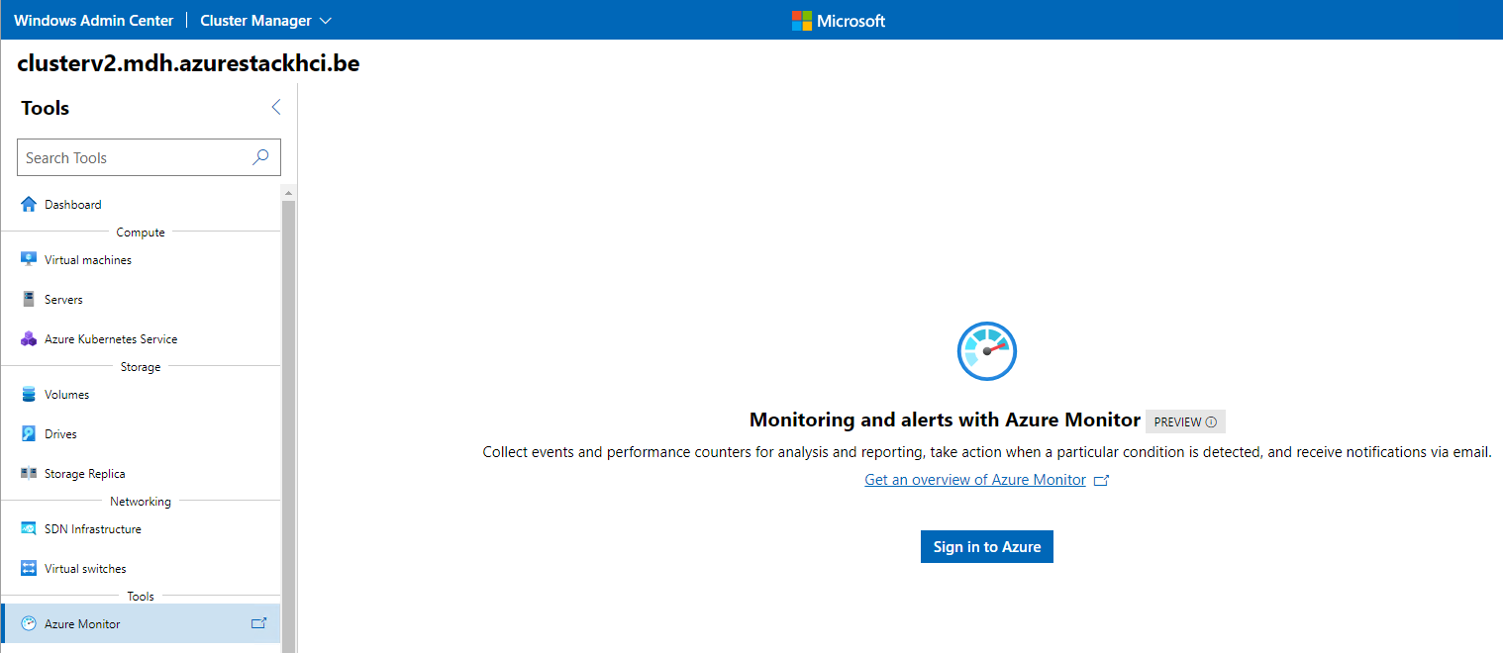

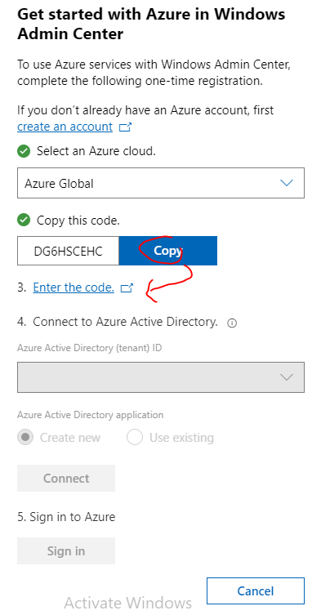

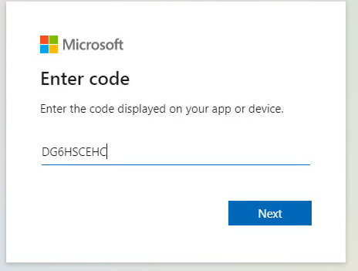

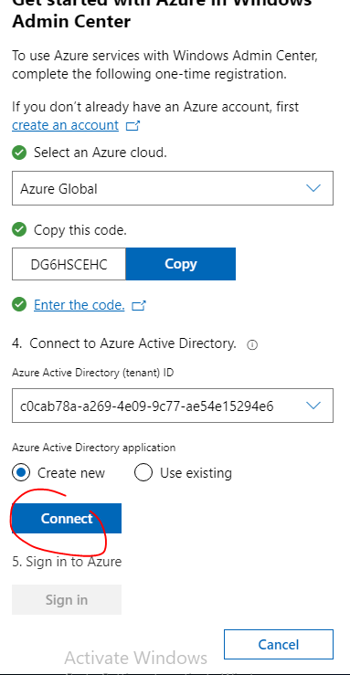

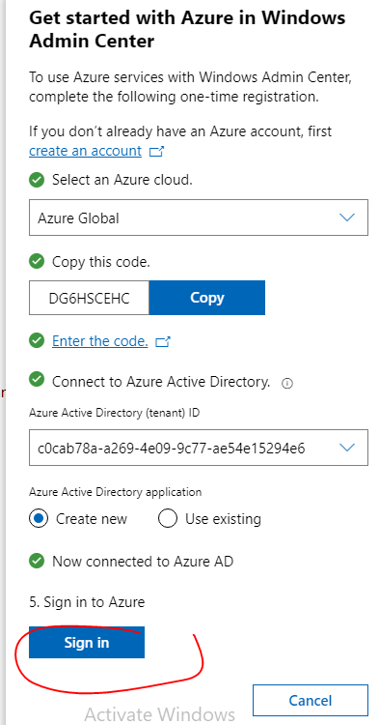

Create a new log analytics workspace

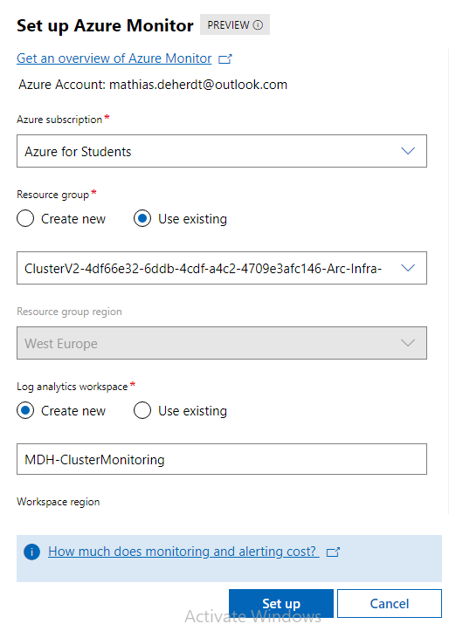

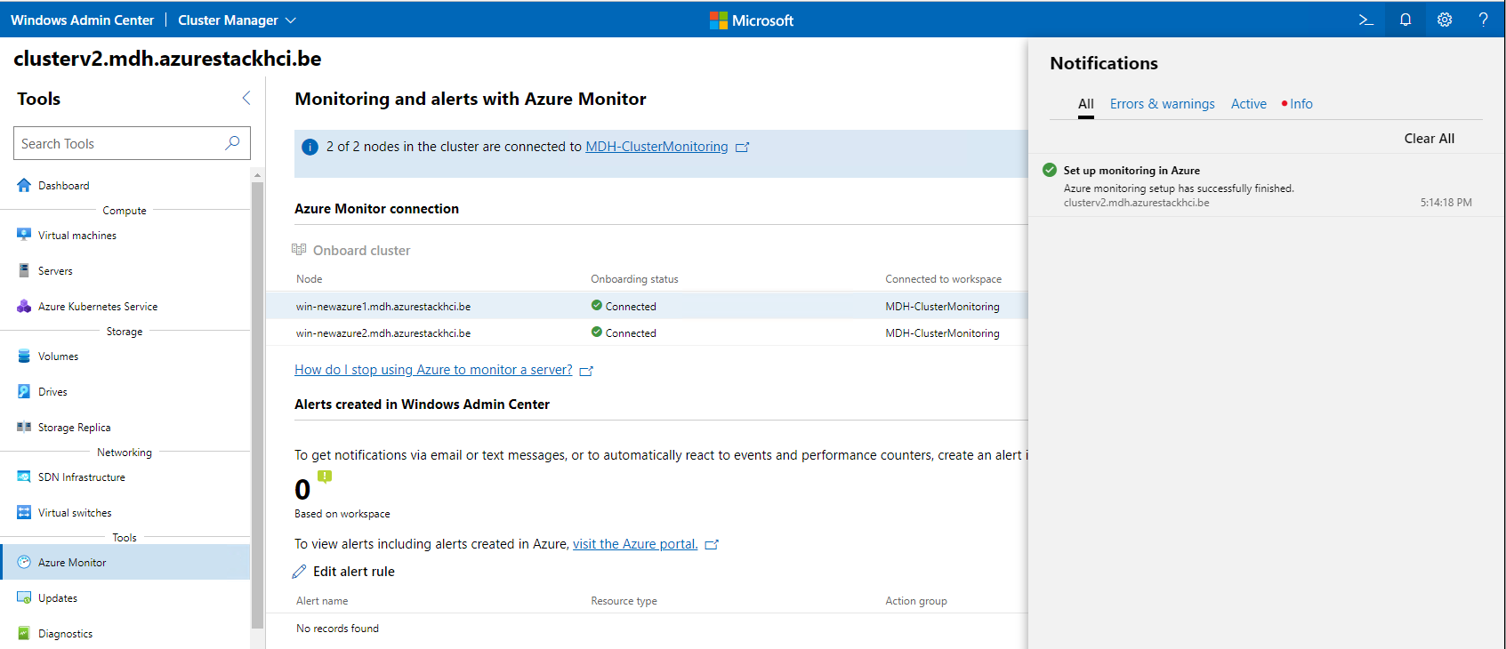

#### Enable logs

In the Azure Portal go to your clusters overview and select “Capabilities”.

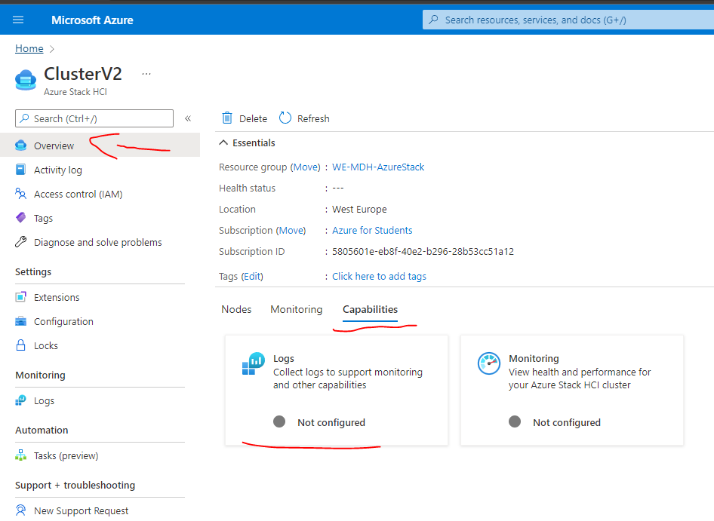

Here we can select our existing workspace we just created in Windows Admin Center

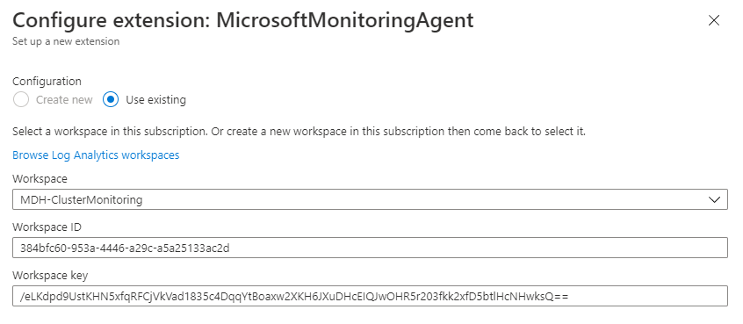

#### Enable Monitoring

In the overview of our cluster under “Capabilities” select “Monitoring” and click on enable.

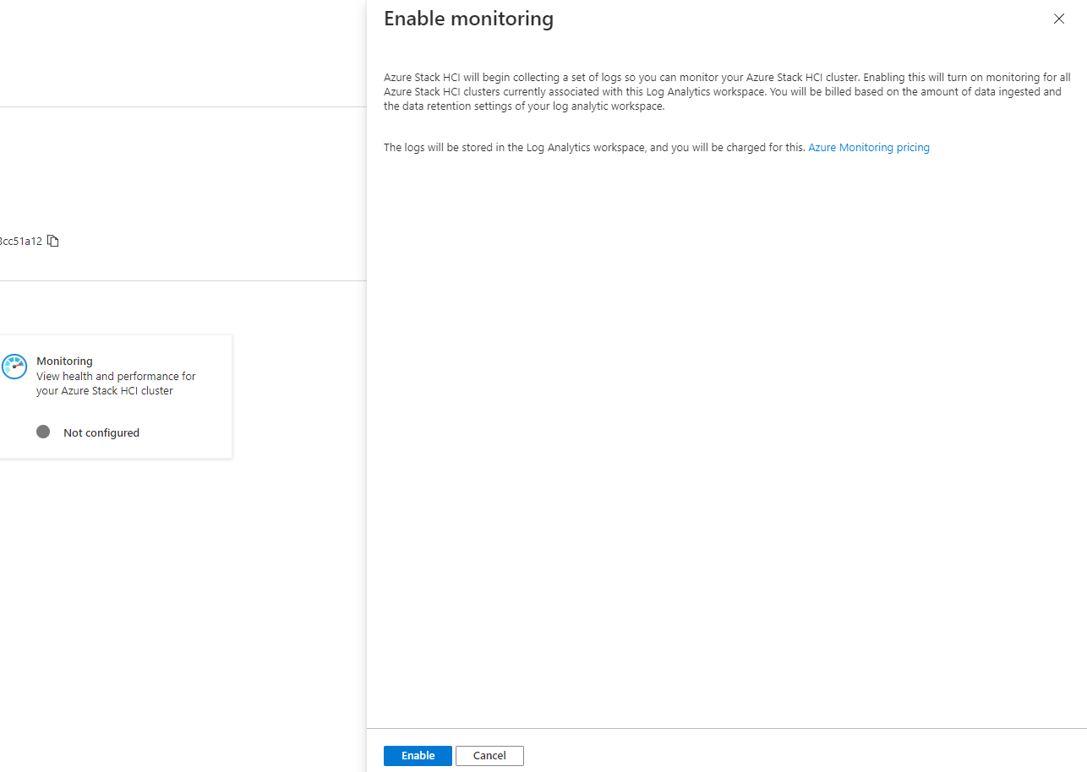

Now in the overview under “Monitoring” after this has loaded (that can take up to 1 hour) you can monitor the cluster.

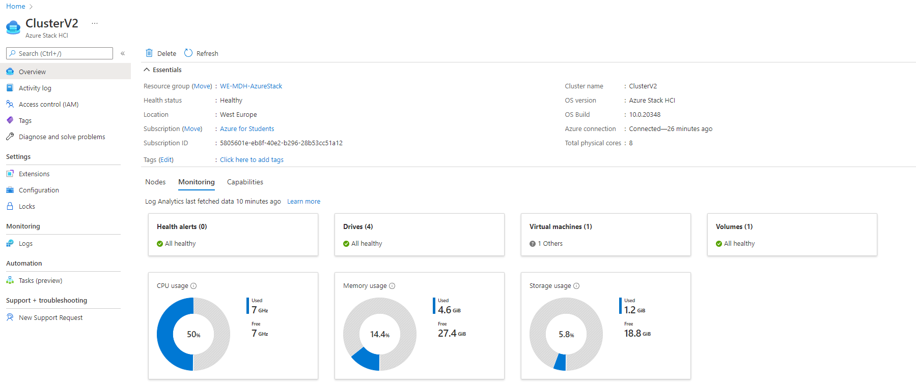

Now the environment is complete enough, at this point we can start to migrate VM’s.

## The code behind everything

### C#: AzureStackHCI.XML

This is the windows users can fill in, here we enter all the configurations for the VM we are going to Create.

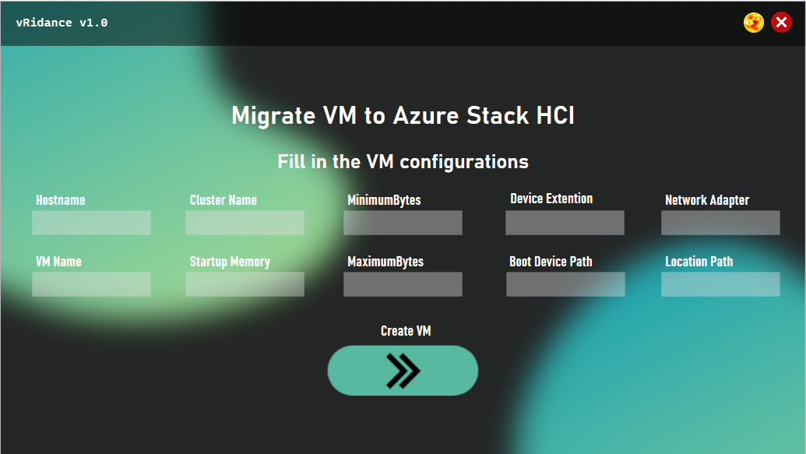

* Hostname = The name of the Host where the VM is being placed
* VMName = Name of the VM
* ClusterName = Name of the cluster where we place the VM
* StartupMemory = How much memory we give at startup
* MinimumMemory = Minimum memory we give to the VM
* MaximumMemory = Maximum memory we give to the VM
* Device Extention = Extention of the harddisk file
* Boot Device Path = Location of the harddisk file
* Network adapter = Name of the network adapter
* Location Path = Location where we store the VM

Example:

* Hostname = Win-newazure1
* VMName = WindowsServer2022-001
* ClusterName = ClusterV2
* StartupMemory = 4GB
* MinimumMemory = 1GB
* MaximumMemory = 4GB
* Device Extention = VHD
* Boot Device Path = c:\diskpath\disk.vhd
* Network adapter = ComputeSwitch
* Location Path = c:\storagepath\

### C#: AzureStackHCI.XML.CS

#### C#: Using

All the packages that the script will be using.

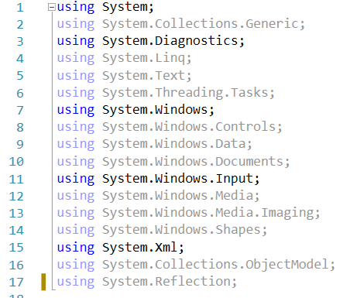

#### C#: Namespace

This is everything in our namespace that will be executed.

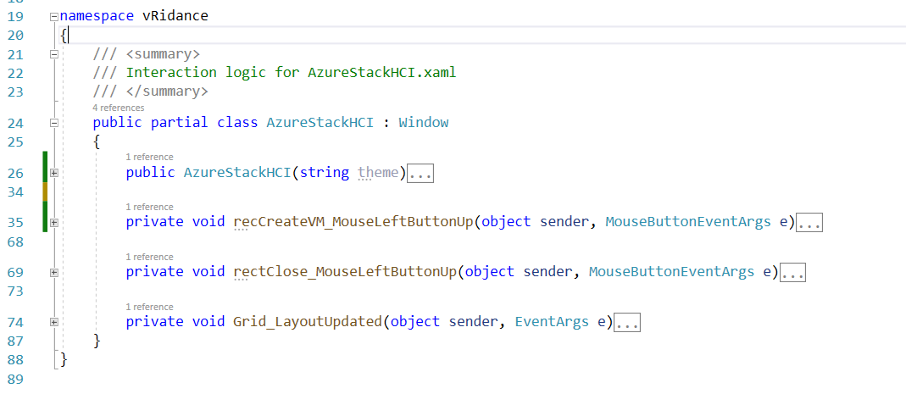

#### C#: public AzureStackHCI

Here we begin the script of the Azure Stack HCI migration page where we can fill in all the configurations. First we disable the button and change the opacity to make it appear lighter.

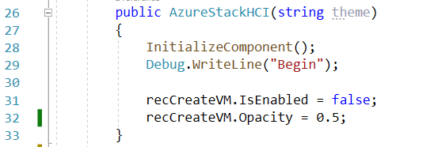

#### C#: Create VM button

Here we read everything insde the textboxes and send the values the to XML configuration file.

First we need to use XmlTextWrite function where we use a variable “xmlWriter2”. Now we can specify the location of the config.xml file and what type of encoding we are using.

With WriteStartElement we create the first element “Configuration” and again we use the WriteStartElement to create a new element under configuration called “CreateVM”.

Now we can use WriteElementString to assign the value to the element. We do this for each value we read out of the textboxes in the XAML file.

After we have send all the values we write an EndElement and WriteEndDocument to close everything.

When writing to the XML file is complete we stop this application.

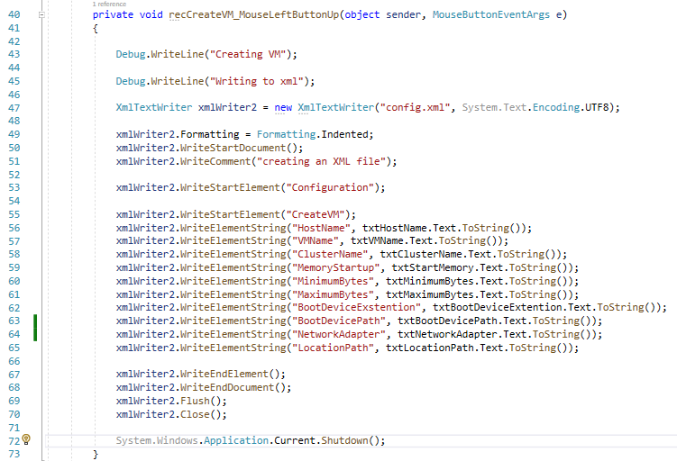

#### C#: Close GUI button

If needed with this function we can close the GUI.

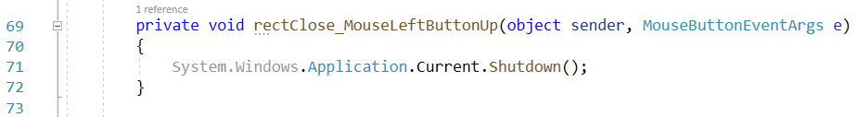

#### C#: Check if textbox is empty

Here we check for each textbox if it is empty or null. If one or more textbox is empty we keep the opacity at 0.5 and disable the button. When everything if filled in we change the opacity to 1 and make the button active.

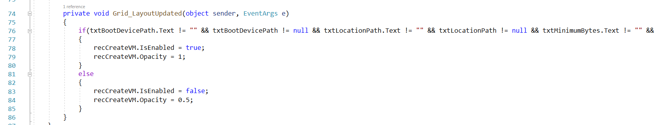

### XML: config.xml

This is being created by our C# script. This is going to be used by the powershell script.

<?xml version="1.0" encoding="utf-8" ?>

<Configuration>

    <CreateVM>

        <HostName>Fill in a Name of the Host where we put the VM</HostName>

        <VMName>Name of your VM</VMName>

        <ClusterName>Name of the cluster</ClusterName>

        <MemoryStartup>INT + GB 🡪 example 4GB</MemoryStartup>

        <MinimumBytes>INT + GB 🡪 example 1GB</MinimumBytes>

        <MaximumBytes>INT + GB 🡪 example 4GB</MaximumBytes>

        <BootDeviceExstention>VHD|VHDX</BootDeviceExstention>

        <BootDevicePath>Path to VHD file 🡪 example c:\temp\disk.vhd</BootDevicePath>

        <NetworkAdapter>Name of the network adapter</NetworkAdapter>

        <LocationPath>Path where we store the VM</LocationPath>

    </CreateVM>

</Configuration>

### Powershell: check-PathXML

This function will check if the xml file is reachable. If not the script is stopped and exited with code 100. In the main-Script function we give a value to XML_Path

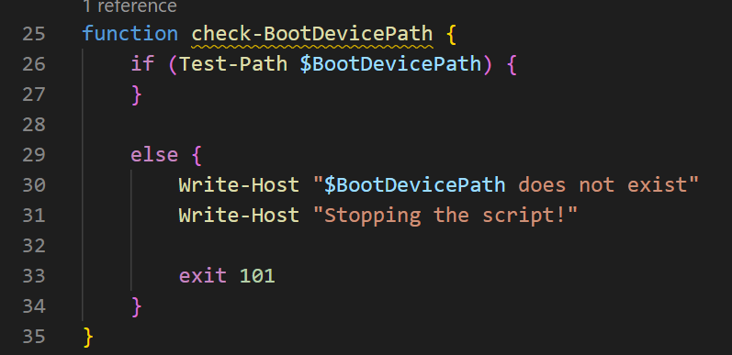

### Powershell: check-BootDevicePath

Here we will check if our path to the VHD file exists and if it is reachable. If not we return errorcode 101

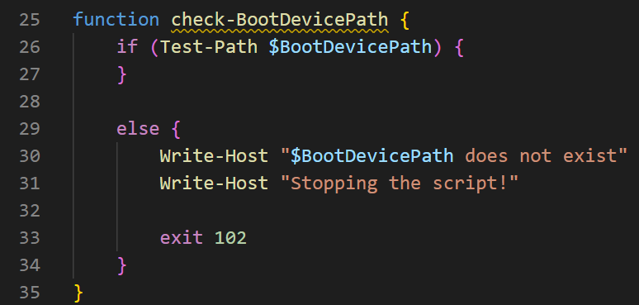

### Powershell: check-BootDeviceExtention

In this fuction we are checking if the value from the xml file are equal to VHD or VHDX. These are the only file extentions that are supported by this script and by Azure Stack HCI for what we a trying to accomplish.

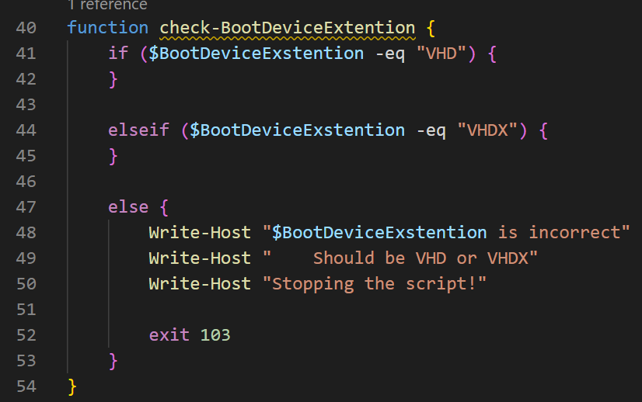

### Powershell: read-DataFromXML

In this function we are reading in our xml file and putting all the values in variables for later use and after everything is put into variables and the necessary check functions done and approved we go to the create-VirtualMachine function. But first let’s take a closer look to the read-DataFromXML function.

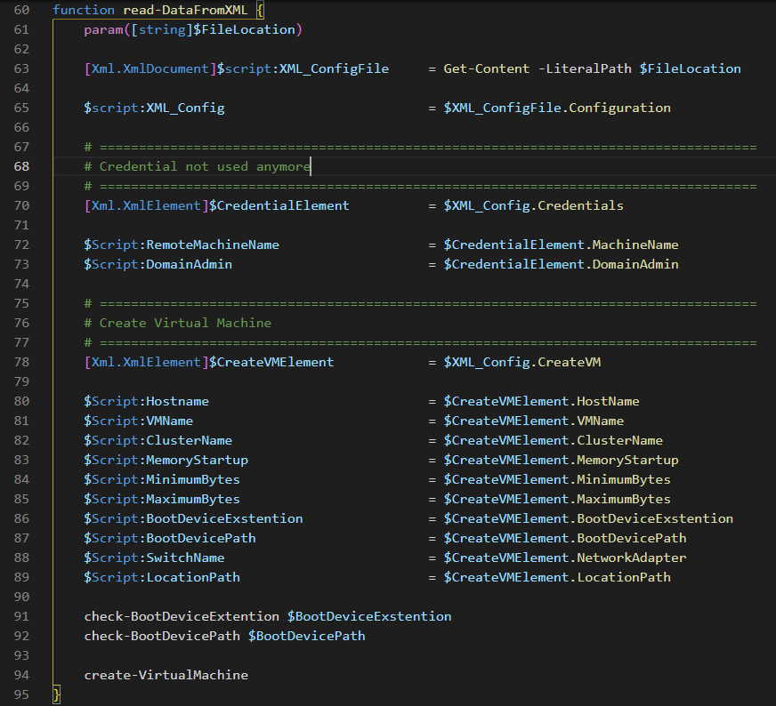

Here we will be reading the whole file from the location and telling our script that it is an xml document so we can read it. Here we read everything in from our configuration element and assign it to the variable XML_Config.

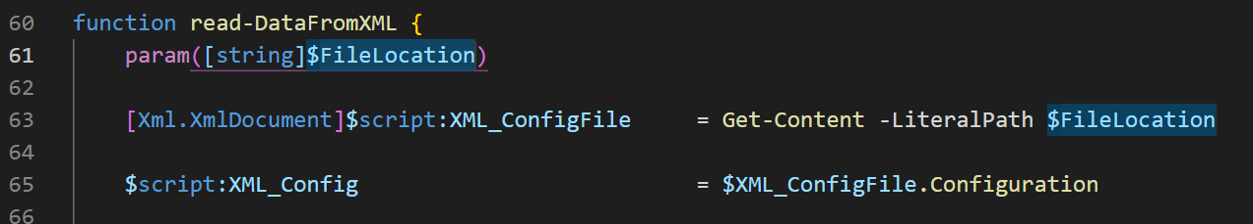

In this part of the code we read in our credential element. We use our previouse created XML_Config variable to tell the script we are using the credential element inside the config element.

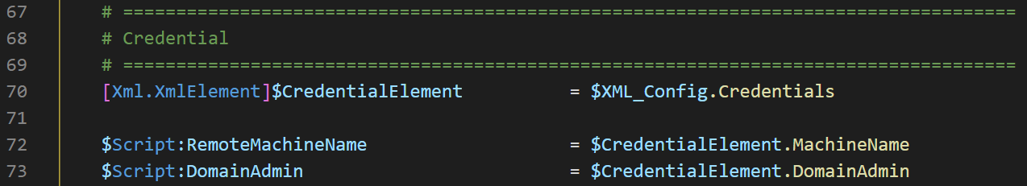

Now we take the XML_Config element and read the CreateVMElement from inside it and assign it as a variable so we can read al the sub elements from CreateVMElement and put it all in variables.

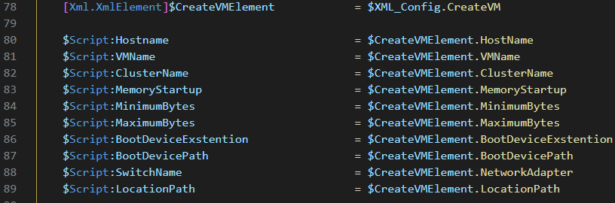

In the final part of our function we do a couple of checks and after they are successfully completed we go to the create-VirtualMachine function where we create a VM using all the variables from the XML file.

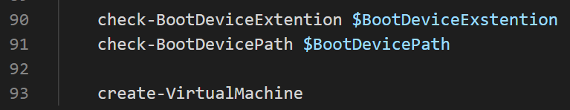

### Powershell: create-VirtualMachine

In this fuction the VM is being created, let’s take a closer look at each part of the function.

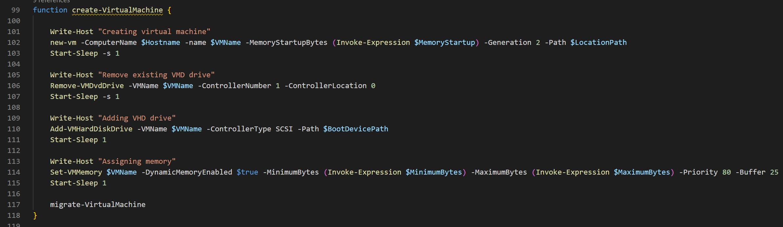

#### New-VM

The new-vm command is part of the Hyper-V module we installed in Windows Admin center. It is used to create a new virtual machine.

* ComputerName = Node where you put the VM
* VMName = Name of the VM
* MemortyStartupBytes = Memory that is given to the VM at startyp
* Generation = Genaration of the VM, 1 = VHD | 2 = VHDX
  + - * + (this did not work for me, I have to use 2 when using a VHD)
* Path = Location for where to store the VM
* SwitchName = Name of the switch we made in the cluster

Example:

* ComputerName = win-newazure1
* VMName = WindowsServer2022-01
* MemortyStartupBytes = 4GB
* Generation = 2
* Path = \\WIN-NEWAZURE1\c$\ClusterStorage\Volume01\VMs
* SwitchName = ComputeSwitch



#### Remove-VMDvdDrive

After creating our new VM it automatically has a harddrive attached to it, we need to remove this one and later we attached our VHD file from the VM we want to migrate.

* VMName = Name of the VM we want to remove the harddrive from
* ControllerNumber = the controller number from which the DVD drive is to be deleted
* ControllerLocation = the number of the location from which the DVD drive is to be deleted

Example:

* VMName = WindowsServer2022-01
* ControllerNumber = 1
* ControllerLocation = 0



#### Add-VMHardDiskDrive

We connect the VHD drive we converted from the VM in vSphere.



#### Set-VMMemory

Here we assign the memory for the VM.



### Powershell: migrate-VirtualMachineToCluster

Here we specify the VM that we want to place onto the cluster.

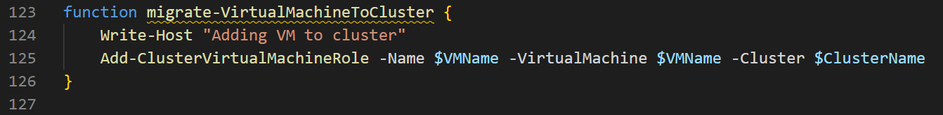

### Powershell: main-Script

This function will start our script and get the location from where this script (and the xml file) are located. Before we go to the read-DataFromXML function, we first need to check if the path to our xml file is reachable, if not the script will stop here.

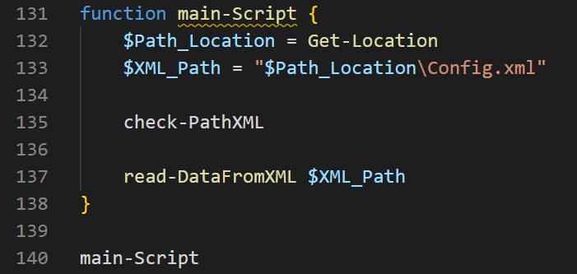

### Powershell exit codes

* 100 = path to the xml file is incorrect
* 101 = path to the VHD (or VHDX) file is incorrect
* 102 = Wrong value in BootDeviceExtention

## Migrate VM

Open you mgmt machine where you can access Windows Admin Center and your Azre nodes.

In the sources folder we provided you can see our source code for vRidance.exe (with all the other files), !Converter.cmd, a powershell script and a xml file.

You will also need to download the StarWind V2V Converter tool. This tool let’s us convert a vmdk to a vhd. You will need to fill in your email address and information and you will get a mail with the download link.

[StarWind V2V Converter - Converting VM Formats (starwindsoftware.com)](https://www.starwindsoftware.com/starwind-v2v-converter#download)

Make sure you have all these scripts at the ready on the mgmt machine, we will use them later on.

### Step 1: Select a VM

On your mgmt machine log into vSphere and look for a VM you want to migrate. Go to its datastore files and download the whole VM folder.

Once downloaded this will be in the downloads folder of the mgmt machine.

Why do we need to do it this way? Well the general idea is that we need the vmdk file of the VM we want to migrate and convert it to a vhd. After converting the harddisk we create a new VM in Azure Stack HCI and attach the vhd file from the vSphere VM to the Azure Stack HCI VM.x

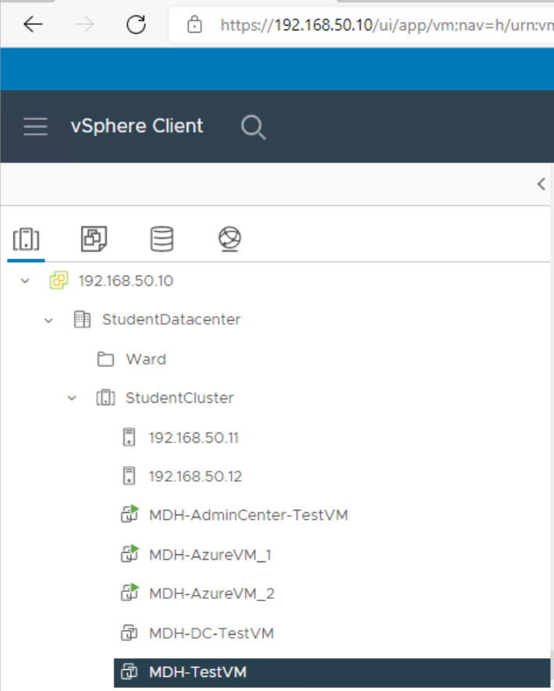

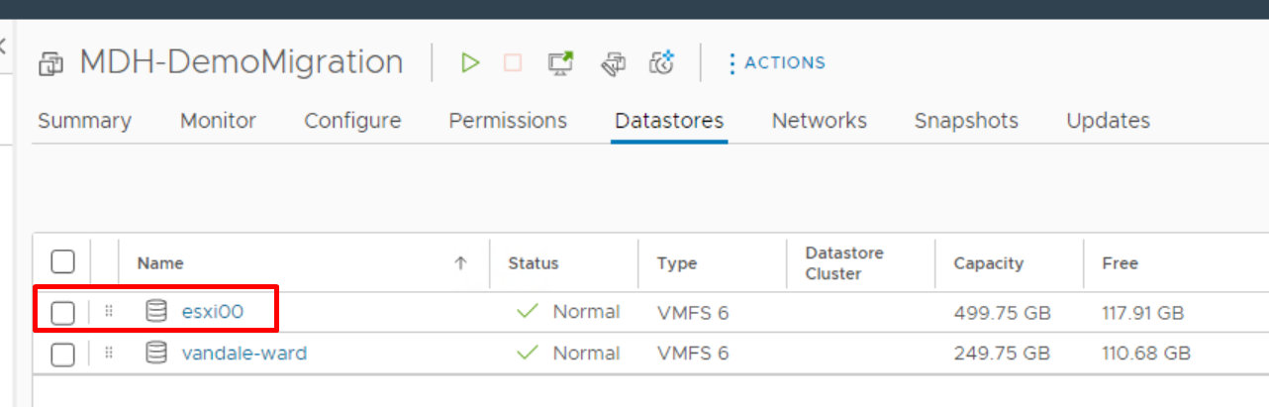

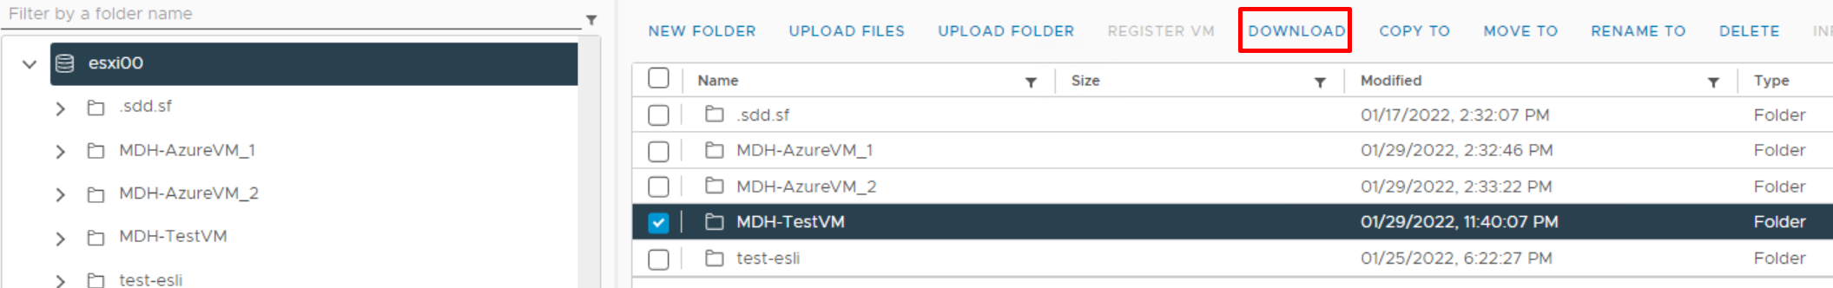

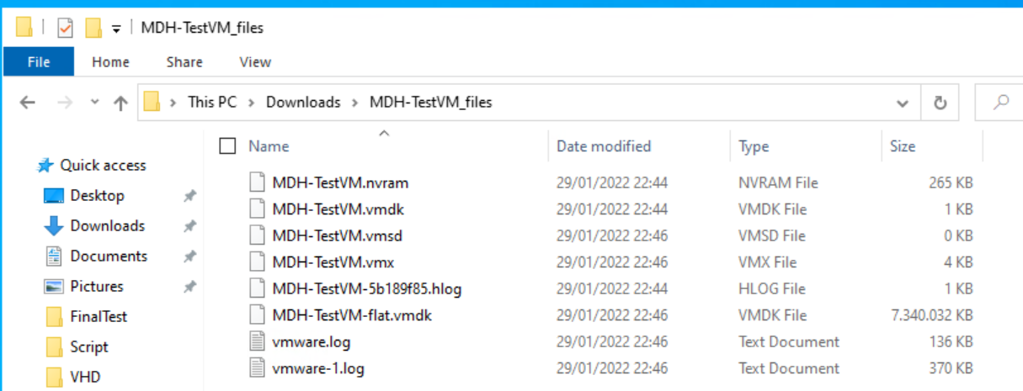

### Step 2: Convert vmdk to vhd

First install StarWind V2V converter from the link we provided.

After installing open file explorer to this path:

C:\Program Files\StarWind Software\StarWind V2V Converter\

Here past “!Converter.cmd” into this folder.

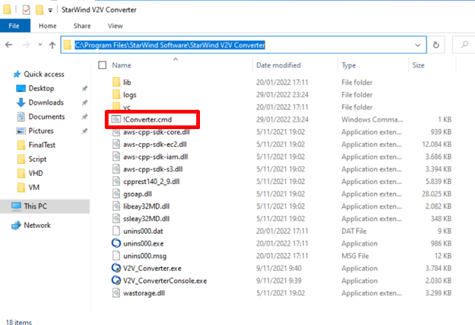

And edit “!Converter.cmd” with notepad. You will see this code:



SET vmdkFilePath=""

SET vhdFilePath=""

V2V_ConverterConsole.exe convert in_file_name=%vmdkFilePath% out_file_name=%vhdFilePath% out_file_type=ft_vhd_thin

* vmdkFilePath = path to the vmdk of the VM from vSphere
* vmdFilePath = Path where we want to store the converted file

example:

* vmdkFilePath = “C:\Users\mathias\Downloads\test-VM.vmdk”
* vmdFilePath = “C:\Users\mathias\Downloads\VHDFiles\conv.vhd”

after editing the file save it and double click on it to start the converting. If everything is correct you should start seeing this window.

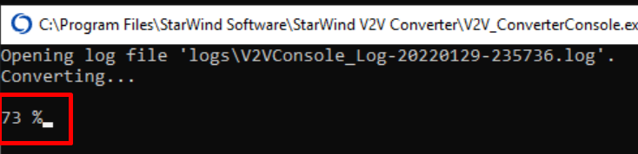

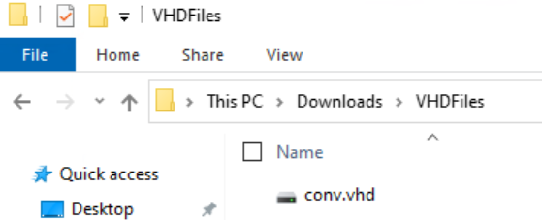

Now cut and paste the vhd file in to the cluster storage. We must copy past this because if we convert and immediately place it onto the cluster storage we must wait upto 3 hours to complete. And there is a lot that can go wrong, if we even lose connection the vhd file can go corrupt so the safest solution is to just copy and past them into the cluster storage.

\\win-newazure1\c$\ClusterStorage\Volume01\VHD\

### Step 3: Start the migration GUI

Open your mgmt machine where we can both access Windows Admin Center and the Azure nodes.

In the sources folder we provided all the necessary files. Simply place them on one of your nodes. I put them on win-newazure1 in this path:

\\win-newazure1\c$\Users\administrator.MDH\Documents

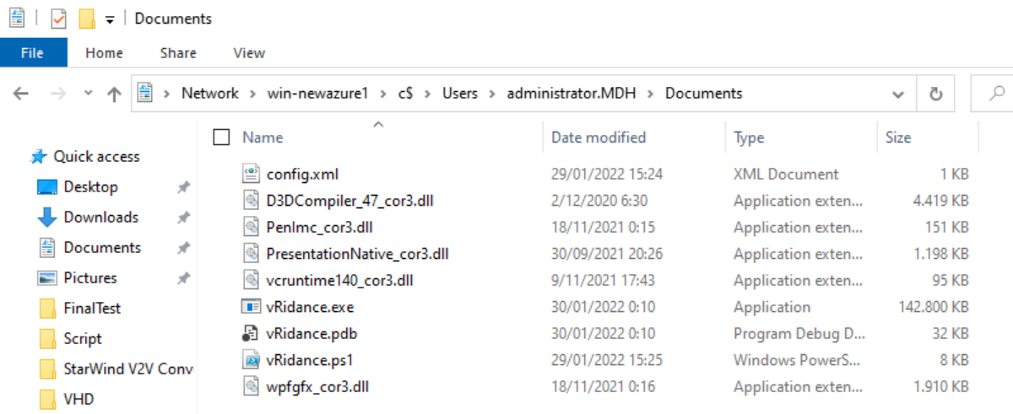

Double click on vRidance.exe, this will open the GUI.

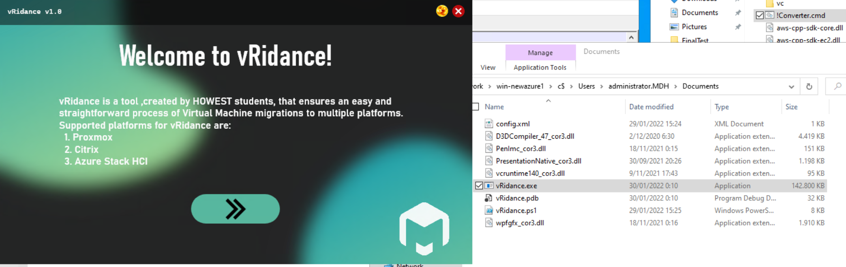

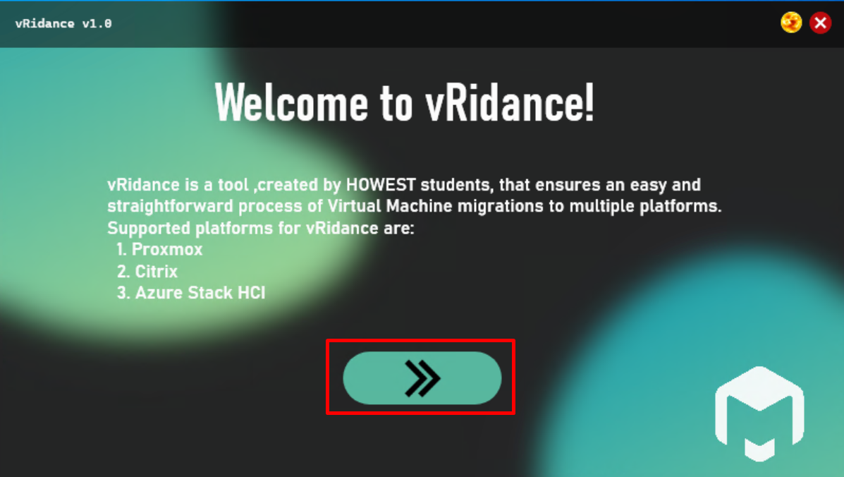

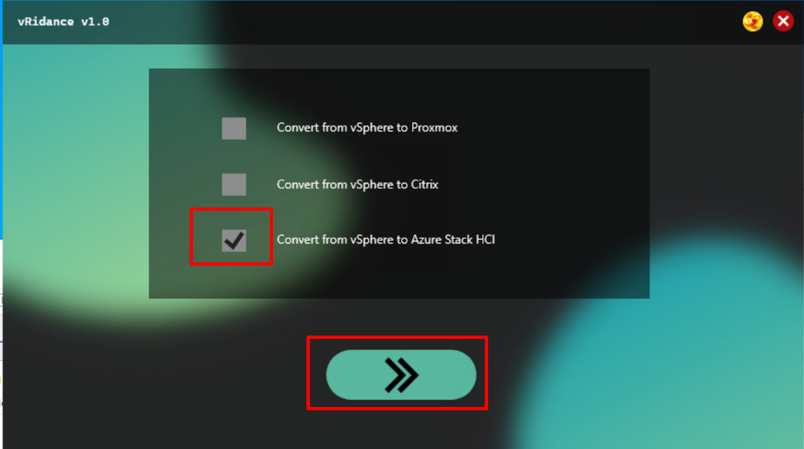

In this window we fill in all the configurations for the VM.

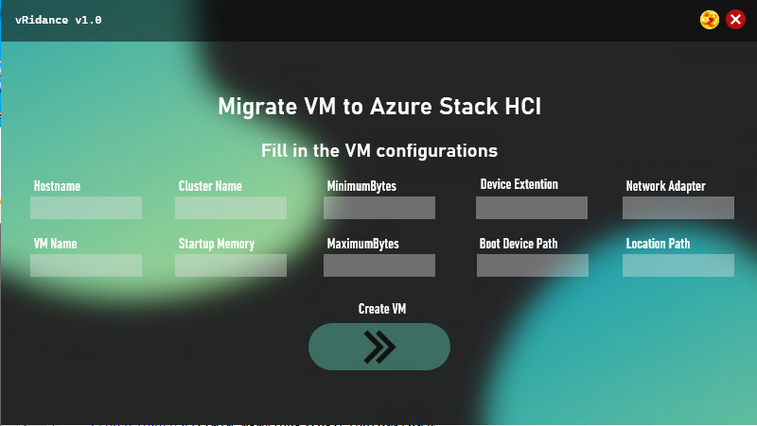

* Hostname = The name of the Host where the VM is being placed
* VMName = Name of the VM
* ClusterName = Name of the cluster where we place the VM
* StartupMemory = How much memory we give at startup
* MinimumMemory = Minimum memory we give to the VM
* MaximumMemory = Maximum memory we give to the VM
* Device Extention = Extention of the harddisk file
* Boot Device Path = Location of the harddisk file
* Network adapter = Name of the network adapter
* Location Path = Location where we store the VM

Example:

* Hostname = Win-newazure1
* VMName = WindowsServer2022-001
* ClusterName = ClusterV2
* StartupMemory = 4GB
* MinimumMemory = 1GB
* MaximumMemory = 4GB
* Device Extention = VHD
* Boot Device Path = c:\diskpath\disk.vhd
* Network adapter = ComputeSwitch
* Location Path = c:\storagepath\

When filling in these textboxes, the code behind this GUI will send all the values into an xml file that the powershell script will need for the migration and installation of the VM.

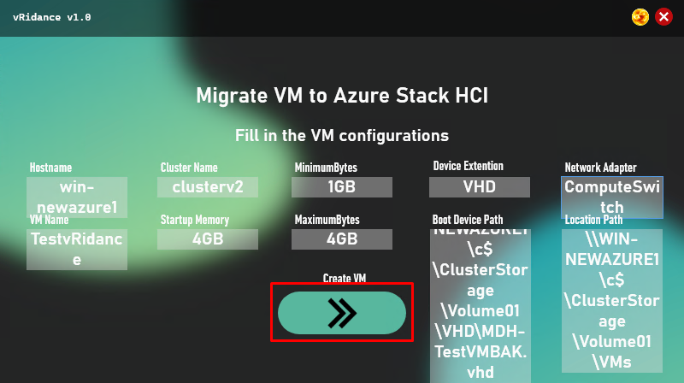

### Step 4: Start the powershell script on the azure node

Now go to the machine with the hostname you typed in. In my case I used “win-newazure1”.

In the source folder copy and past all these files inside the document folder of the user.

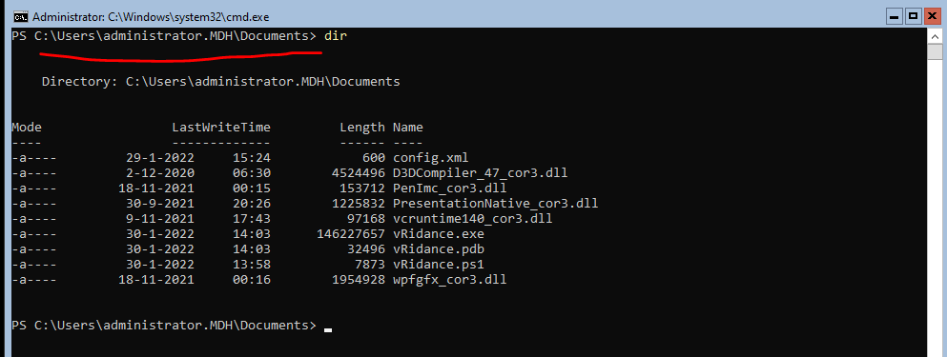

Why must we do this? Well the GUI works with WPF and this eis not supported one these Azure nodes and we only found this out at the last moment.

Now we use a mgmt machine to start and complete the GUI. The GUI makes the config.xml file and after that we go to the Azure Node VM (the hostname we specified) and run vRidance.ps1

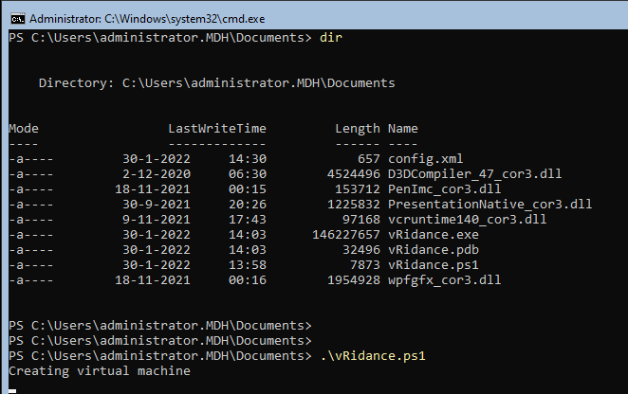

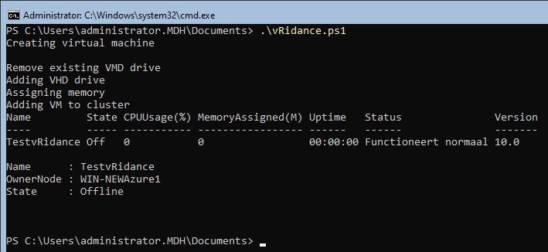

### Step 5: Windows Admin Center

Open windows admin center, and log into the cluster. In the virtual machine tab you should see the VM.

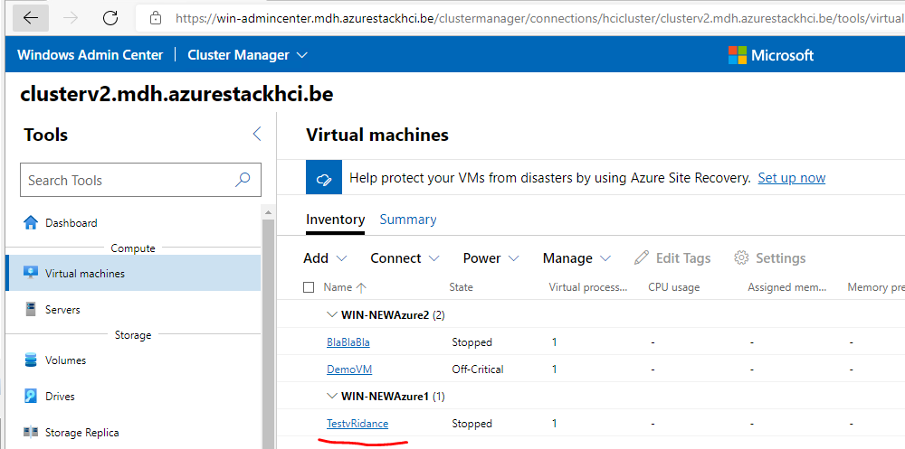

# Citrix